Contact HR Consultant for CV No: 2049918
E-mail: response@gulfjobseekers.com
Website: http://www.gulfjobseeker.com/employer/cvdatabasepaid.php
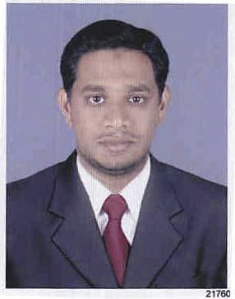
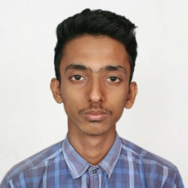

RResume

Job applied: Supervisor
OBJECTIVE:

- Result-oriented, professional experienced in an excellent organization and in
customer service entering, reviewing and revising data and managing multiple
projects of different deadlines. I can work independently and as part of a team using exemplary communication skills. A strong work ethic combined with a commitment to excellence in all projects undertaken. Good Microsoft application skills and high proficiency in English language. My goal is to provide a professional service to the best of my abilities and expertise.
SUMMARY OF EXPERIENCE:

- Hardworking, detail and team oriented.
- Works well independently or with groups, extremely organized and a fast learner.
- Excellent customer service skills.
- Strong communication skills.
- High level of accuracy and attention to detail.
- Organization skills land consistent in the work.
- Time management and training skills.
WORK EXPERIENCE
Company : Dimple Fashions, Sharjah, UAE
Period : Feb 05, 2013 - Till Date
Position : Sales Coordinator

RESPONSIBILITIES

1 year of Sales coordinator experience at Dimple Fashions showroom Sharjah UAE.
Good knowledge of sales in fashion/ garments industry.
To carry out Quality check of Women’s wear. Men’s wear and Kids wear.
To lead a team of sales people involved and achieve sales target with good knowledge of accounting.
Work in Sales personnel to provide product, business and technical knowledge in support of sales
Activities.
Responsible for understanding business and technical problems addressed by the products including key regulations, evolving business needs.

Company : Ever Fashions, Bangalore, India
Period : April 15, 2004 - Jan 15, 2013
Position : Sales Manager
RESPONSIBILITIES
- 10 years of Sales Manger experience at Ever shine showroom Bangalore.
- Good knowledge of sales in fashion/ garments industry.
- To carry out Quality check of Women’s wear. Men’s wear and Kids wear.
- To lead a team of sales people involved and achieve sales target with good knowledge of accounting.
- Work in Sales personnel to provide product, business and technical knowledge in support of sales activities.
- Responsible for understanding business and technical problems addressed by the products including key regulations, evolving business needs.
Company : Foot Style, Bangalore, India
Period : November 15, 2000- March 31st2004
Position : Sales Manager
RESPONSIBILITIES

- Ensure that Sales, Product Marketing and development receive such support as they request.
- Measure and track service and productivity levels updating both the team and senior management on those aspects of performance, responding according to that ensure performance targets are achieved.
- Customer friendly nature and strong communication skills.
EDUCATION:

- Passed exam of PUC from Board of Bangalore Government.

LANGUAGES KNOWN:

- Fluent: English, Hindi, Malay, Telugu, Tamil, & Kannada

PERSONAL INFORMATION:

Nationality : Indian
Date of Birth : 14-Aug-1977
Marital Status : Married
Sex : Male

DECLARATION:

I hereby declare that all above mentioned details are true and correct to the best of my knowledge

