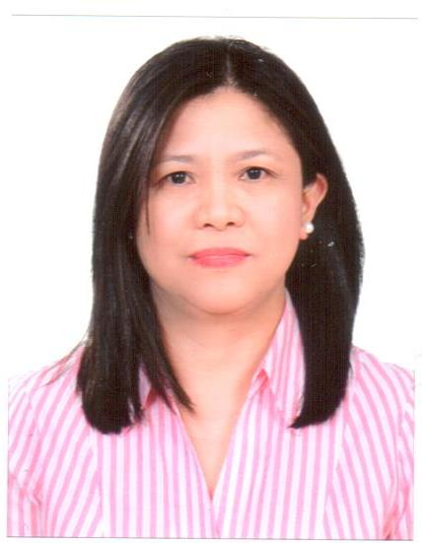

AMALIA
AMALIA.341697@2freemail.com

Position Applied for: Accountant / General Accountant / Chief Accountant

Career objective

Detail-oriented accountant seeking a position where analytical and technical skills can be further developed and utilized to improve the company’s profitability and contribute to its growth.
PROFESSIONAL QUALIFICATIONS

Certified Public Accountant (CPA)

Bachelor of Science in Commerce, major in Accounting
Saint Mary’s University
Bayombong, Nueva Vizcaya, Philippines
Graduated, March 1989

SKILLS

- Accounts finalization.
- In-depth knowledge of Tally. ERP 9 accounting software application.
- Proficient in Microsoft Office (Word, Advanced Excel, Outlook and PowerPoint).
- Detail-oriented, competent and diligent.
- Strong communication and interpersonal skills
- Time management and problem solving.
- Strong analytical and technical skills.
- Knowledge of Dubai trade customs clearance and documentation. (E-Mirsal II)
- Knowledge of International Financial Reporting Standards (IFRS) and IAS.

WORK EXPERIENCES

GENERAL ACCOUNTANT
Arcom Heavy Equipment FZE
P.O. Box 17412, Between 7 & 8 RA
Jebel Ali Free Zone, Dubai, U.A.E.
June 17, 2006 to present

Duties and Responsibilities:
- Maintenance of accounts in Tally.ERP 9 up to finalization and MIS reporting.
- Prepare cash flow statement, bank reconciliation, in-house financials on a monthly basis or as needed.
- Cash management, WPS, online banking, bank deposits and bank transfers.
- Coordinate with external auditors and organize yearend audit procedure.
- Efficient handling of Import and Export Letter of Credit.
- Coordinate with banks regarding corporate credit facilities and ensure compliance of required documentation and securities. Arrange financial reports as required.

Duties and Responsibilities:

- Organize on time payment of bank loans and utility bills.
- Ensure accounting policies, procedures and internal controls are implemented.
- Monitor trade receivables and prepare Statement of Accounts.
- Maintain sales, purchases, receivable, payable and inventory register.
- Guarantee that all costs related to a specific inventory are properly accounted.
- Verify purchase orders & invoices and arrange payment on time.
- Verify sales invoices & custom import/export documentations for shipment/delivery purposes and compute tax/duties on imports.
- Generate customs declaration for import & export goods.
- Verify receipts and all petty cash vouchers
- Collection of rent from tenants and payment of real estate property service charges.

.
ACCOUNTANT
Valdez Accounting Firm
Certified Public Accountant and Management Office
Bambang, Nueva Vizcaya, Philippines
March 01, 2004 to March 31, 2006

Duties and Responsibilities:

- Perform bookkeeping jobs to Clients usually weekly or bi-monthly; provide internal accounting reports as needed.
- Prepare income tax return for business establishments.
- Prepare Clients Financial Statements and other documents required for loan, tax and other purposes.
- Manage Clients accounts payable, accounts receivable accounting and prepare Statement of Accounts for debtors.
- Prepare Clients bank reconciliation statements.

Assistant Manager
WPC Rice Grains Trading & Milling Co.
Solano, Nueva Vizcaya, Philippines
September 01, 1995 to February 10, 2004

Duties and Responsibilities:

- Assessment of the variety and quality of rice grains for proper pricing.
- Calculate the overhead expenses and set-up selling price of the rice grains purchased.
- Deal with rice traders and millers.
- Prepare and pay salary of laborers.
- Prepare income tax return.
- Provide credit to customers, monitor their farming activities and collect payments.

Accounting Clerk / Cash Clerk
Land Bank of the Philippines
Solano, Nueva Vizcaya, Philippines
January 07, 1991 to August 30, 1995

Duties and Responsibilities:

- Prepare daily Income Statement and Balance Sheet.
- Prepare payroll bi-monthly and handles petty cash.
- Prepare monthly contribution/payment for Social Security System & Income Tax.
- File payments and receipts vouchers.
- Compute Clients’ loan outstanding and restructuring of loans.

Bank Teller
Philippine National Bank
Ilagan, Isabela, Philippines
January 05, 1990 to July 05, 1990

Duties and Responsibilities:

- Receive deposits, process current and savings accounts withdrawals.
- Verify and cash cheques.
- Maintain cash count at end of the day.
- Verify authenticity of foreign currencies presented.
- Politely answer customer enquiries and refer them to the proper service area.
- Maintain highest level of confidentiality with all information received.
- Inform management of unusual behavior of clients and any threats for the safety of the bank and its personnel & other clients.

SEMINAR / TRAINING ATTENDED IN UAE

Letter of Credit training workshop
Jood Palace Hotel (Taj Place Hotel), Deira, Dubai, U.A.E
August 24, 2008

Trakhees Accreditation Program
Cedar, Jebel Ali, Dubai, U.A.E.
October 13, 2016

PERSONAL DATA

Nationality : Filipino
Civil status : Married
Religion : Christian
Visa Status : Employment visa (free zone)

I hereby certify that all above information are true and correct with the best of my ability.

