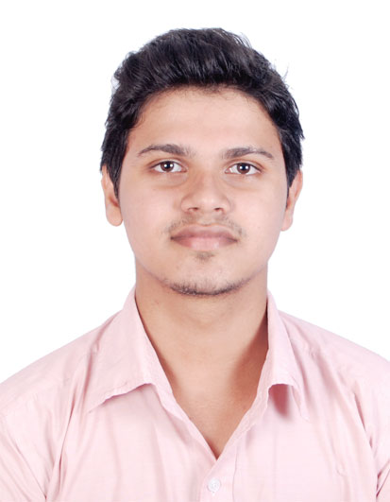
CURRICULUM VITAE

FAZAL

E-mail: fazal.341719@2freemail.com

Career Objective

Seeking a position to utilize my skills and abilities in the Electrical Engineering field that offers professional growth while being resourceful, innovative and flexible. Honours the values of professionalism, punctually and hard work. Possesses good managerial skills, leadership quality and respects the collective potential of human resources. A person who will be completely sincere to the organization.

Work Experience

Organization : Thoomba Thamir Builders & Developers
Designation : Electrical Site Engineer

Location : Calicut, – Kerala – India.

Period : From August 2015 – September – 2016

Job Profile
- Handled a project having 1000 KVA Transformer and 2 nos., 400 KVA DG.
- Maintained good professional relationship with suppliers and contractors.
- Evaluated and resolved all project technical problems
- Tested system for discrepancies in construction projects and objectives.
- Ensured project completion within budget and on schedule.
- Tested all products for correct installation and operation.
- Kept all clients architects and consultants updated on project progress.
- Supervised all subcontractor work to ensure compliance with client requirements
- Maintained all safety and quality control project construction materials.
- Documented and submitted all conducted work reports to clients.

Organization : SEDEER MEDICAL
Designation : Service Engineer

Location : Doha, Qatar

Period : From September 2016 – December 2016

Job Profile
Medical equipments installation and maintenance

Education Qualifications

September 2011 to May 2015 Bachelor of Technology – Electrical and
Electronics Engineering
From Government college of Engineering
Kannur, Kerala, India

March 2009 to March 2010 Umbichi Hajee Higher Secondary School,
Chaliyam, - State Board ( 12th Grade)
Kerala, India

March 2007 to March 2008 Umbichi Hajee Higher Secondary School,
Chaliyam, - SSLC ( 10th Grade)
State Secondary Board , Kerala, India

Computer Literacy

Programming language C, C++, Java
Good Knowledge in PLC
Platform Windows
Software/Package Mat lab
Auto CAD
Electrical CAD
Revit MEP .

Training and Achievements

- Attend PLC training held at GCE Kannur, Kerala, India
- Conducted Industrial Training at KDPP (Kozhikode Diesel Power Project, at Nallalam, Kerala, India.
- Conducted Industrial visit at HVDC power grid corp. Kolar, Karnataka, India
- Hydro electric power plant Idukki, Kerala, India

Languages known

- English, Hindi, Tamil and Malayalam

Other Skills

- Hard working and willingness to learn as a team player

Languages known
- Good listener
- Self motivator

Hobbies

- Internet Surfing
- Playing Football & Cricket

Personal Details

ails

Date of Birth : 02/05/1992
Religion \ Caste : Islam / Muslim
Sex : Male
Nationality : Indian
Marital Status : Single
Languages Known : English, Malayalam, Hindi and Tamil
Health : Excellent

Declaration

ails

I hereby declare that all the fact stated above is true and correct in best of my knowledge and belief.

FAZAL

