EGOMHAN
EGOMHAN.341738@2freemail.com
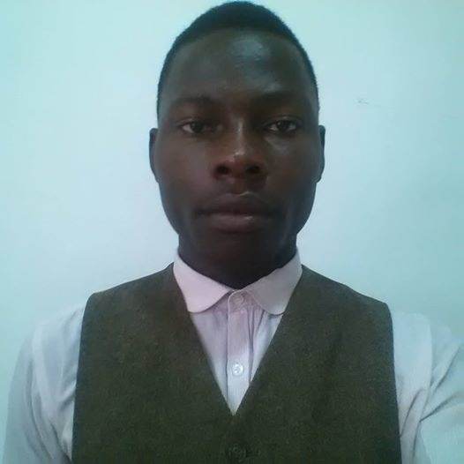
PROFESSIONAL SUMMARRY
Innovative computer Technician with 5years in computer maintenance and repair. Advanced knowledge of all version of windows operating system (including Windows 10), all version of Microsoft office (including office 2016), skilled at recovering deleted, lost or formatted files, also skilled in programming as well as extensive experience with almost all brand of systems (HP, Samsung, Compaq, Apples etc ).
Finally, am a skilled instructor.
SKILLS

- Desktop and laptop repair
- Teaching skill
- CCTV surveillance cameras installation
- Internal components installation
- Anti-virus solutions
- Internet setup and repair
- File transfers expert
- Self-starter
- Detail-oriented
- Strong communication skills
- Focused
- Patient
- Innovative thinker

WORK HISTORY
SUPERVISOR AND MAINTENANCE PERSONNEL (IT) JANUARY, 2012 TO CURRENT
BLINKERS LIMITED- ASOKORO, ABUJA-NIGERIA.
- Maintained 100% uptime on company networks through careful and preventative maintenance.
- Resolved virus and malware issues with a 100% success rate.
- Resolved 6 technical support per week.
- Set up and configured hardware and software on company computers.
- Set up equipment for employees, including installing cables and hardware.
- Installed software and operating systems on company computers.
- Maintained accurate hardware and software inventories.
- Restored data, operating systems, files, document and drivers.
- Trained both internal and off-site users in repairing and resolving recurring issues.
- Resolved computer hardware and software, printing, installation, word processing, email and operating system issues.
- Repaired and replaced hardware.
- Ordered necessary supplies and part to repair malfunctioning hardware.
- Installed CCTV surveillances cameras.

INFORMATION TECHNOLOGY(IT) SUPPORT, MARCH, 2015 TO JUNE, 2015.
ECONOMIC COMMUNITY OF WEST AFRICA STATE (ECOWAS) COMMISSION – PLOT 101, YAKUBU GAWON CRESCENT, ASOKORO ABUJA-NIGERIA.
- Resolved virus and malware issues with 100% success rate.
- Set up Local Area Network issues and resolved internet issues.
- Set up equipment for employees, including installing cables and hardware.
- Repaired and replace hardware, including All in one desktop, laptops, printers and scanners.
- Recovered files from crash hard disk, restored operating systems.

EDUCATION
NATIONAL CERTIFICATE OF EDUCATION (NCE): COMPUTER/PHYSICS, 2016
FCT COLLEGE OF EDUCATION ZUBA. – KM1, AFTER KADUNA/LOKOJA FLYOVER ABUJA, NIGERIA.

DIPLOMA IN COMPUTER
LAVEGA TECHNOLOGIES: 2012
DAWAKI SULEGA, NIGER STATE-NIGERIA

HIGH SCHOOL DIPLOMA: 2010
GOVERNMENT MODEL SCHOOL – SULEJA, NIGER STATE-NIGERIA.
PERSONAL INFORMATION
DATE OF BIRTH: 30TH JULY, 1992.
SEX: MALE
HOBBIES: SOCIALIZING AND COOKING
NATIONALITY: NIGERIA
LANGUAGE: ENGLISH AND ESHINA

