RINCY
RINCY.341742@2freemail.com
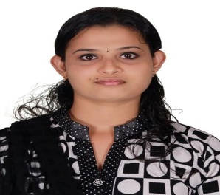
Objective
Seeking a position as a nurse in a reputed hospital where I could serve to the patient and help the organization in building a good image.
Qualification
- Done bachelor of nursing from Snehodaya College Of Nursing in year 2016.
- Passed senior secondary from Little Flower Higher Secondary school Irinjalakkuda with science-biology subject in year 2011 with 70 %.
- Passed secondary education from Don Bosco Higher Secondary School Irinjalakkuda in year 2009 With 85 %.
Trainings
Learning’s include
- Helping the doctors in checking the patient.
- Performing basic checkups like BP check, weight check etc.
- Attending patients need basic treatments like bandage, injections etc.
- Assisting senior doctors in operations.
- Daily check up of patients.
- Responsible for daily dose and routine injection of patient.
- Attending patient in the ICU ward.
Personal Skills
- Polite and soft in nature.
- Good sense of humor.
- Can manage the problems easily.
- Good decision maker.
- Loyal towards my work and duties.
Hobbies
- Watching Movies.
- Listening Music.
- Reading fiction stories.
- Cooking.
Extra Curricular Activities
- Organized Blood donation camp during college.
- Once in a month used to go to the orphanage and spend time with orphan children.
- Playing chess.
Personal Details
Date of birth: 13-10-1992
Languages known: English, Hindi , Malayalam and Tamil

Declaration

I hereby declare that the above written particulars are true to the best of my knowledge and belief.

