CURRICULAM VITAE
DHA
Dha.341764@2freemail.com

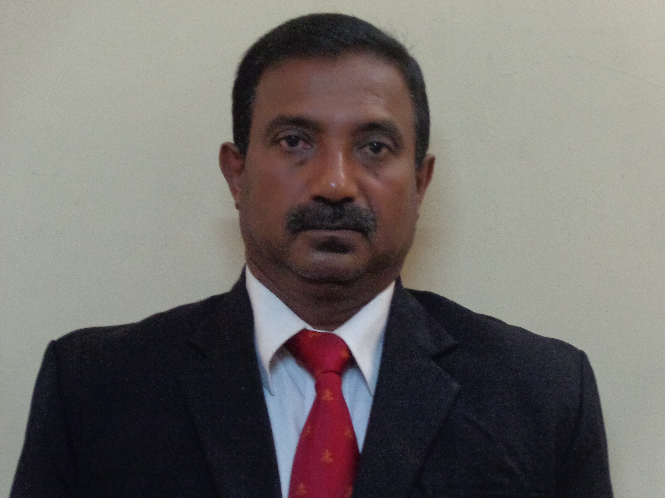

PROFILE

A highly organized, take charge professional with more than twenty-eight years of Human Resources and Military experience. Strong problem solving and decision making skills with the ability to develop and implement effective action plans. Demonstrated experience in the coordination of all aspects of recruiting, training and retaining quality employees. Commitment to detail in doing the job right the first time in completing all projects. Excellent communication and presentation skills. A team leader, providing motivation and training by example.

PROFESSIONAL QUALIFICATIONS

- Aspects of Negotiations including Diplomatic Negotiation at Ministry of Youth
Affairs and Skill Development – Colombo (2011).
- Certificate Course in Productivity Concepts, Tools & Techniques at National
Productivity Secretariat Colombo (2012).
- Counselling Course – National Dangerous Drugs Control Board, Colombo
(2013).
- 28 Years Military Service as a Commissioned Officer (Colonel) Sri Lanka
Army.
- Certificate Course in MS office Package.- ESOFT METRO CAMPUS
- Certificate Course in Human Resource Management (CCHRM)-IPM

JOB RELATED TRAINING COURSES

LOCAL (Military)

- Platoon Command Course - Infantry Training schools Minneriya.
- Platoon Command Course - Army Training school – Maduru Oya – (1992).
- Unit Administrative Course Headquarters Logistic Command at Kosgama –
(1995).

OVERSEAS (Military)

- Basic Military Training (Gentlemen Cadet) at Officer Training School -
Pakistan (1986)
- 81 mm Mortar Course – Home of Infantry MHOW India (1995)
- Special Young Officer Course 28 - Pakistan (1997)
- Junior Command Officer Course 85 at College of Combat – India (1999)
- Senior Command Course 120 at War Collage – India (2011)

EXPERIENCE: SRI LANKA ARMY
Colonel Administration – 2014 at Army Training Command at Diyatalawa
Colonel General Staff - 2012 Bureau of the Commissioner General of Rehabilitation - Colombo
Colonel General Staff – 2008 to 2012 at Task Force – 3 Mankulam
Commanding Officer 2007 to 2008 at Army Training School - Maduru Oya
Sector Commander 2007 Operation Colombo City security - Sector 01
General Staff Officer I 2005 to 2006 at Security Forces Head Quarters - Jaffna
General Staff Officer II 2005 to 2005 at Army Headquarters - Colombo
General Staff Officer II 2000 to 2002 at Logistics Command at Kosgama.
Brigade Major 1997 to 2000 at 513 Brigade & 544 Brigade at Elephant Pass.
2nd in commander 2002 to 2005 at 12th Battalion of the Gemunu Watch in Batticaloa & Jaffna.
Commanding Officer 2006 to 2007 at 9th Battalion of the Gemunu Watch in Batticaloa & Jaffna.

MAJOR OPERATIONS IN NORTH AND EAST
- Vadamarachchi campaign.
- Trhivida Balaya.
- Akunu Pahara.
- Rivi Resa Meheyuma.
- Jayasikuru Meheyuma.
- Balawegaya I, II,III.
- Thoppigala Meheyuma.
- Humanitarian Operation.
DECORATIONS AND AWARDS MEDALS
- Vadamarachchi Operational Meda.
- Purnabhumi padakkama.
- North and East operational medals.
- North Humanitarian operation.
- East Humanitarian operation.
- Riviresa Campagain.
- 50th Independence anniversary medals.
- Sri Lanka Army 50th anniversary medals.
- Sri Lanka Armed services long service medals.

Academic Qualifications
- Studied at Bandaranayaka College Gampaha (1976 – 1983)
- Successfully completed GCE, A/L examination – 1983
- Successfully completed the GCE, O/L examination – 1981

Extra curricular activities in college
- A College Senior prefect
- A Member of the college Athletics team.
- A Member of the college volleyball team.
- A Senior member of the school cadetting.
- A Member of the old boy’s association.
Summary
- Solid Mature background in Administration and Human Resources Management with 28 years of Experience as a commissioned officer (Colonel).
- Realistic and practical Experience to handle any kind sudden situations.
- Good command and Leadership skills to guide subordinates towards organizational objectives.
- Effective communication skills with proper public Relationship Ability.
- Organized, highly motivated problem solver.
- Skilled at learning quickly & working well under pressure/stress.
- More than 20 years professional experience on counselling and stress Management.
- Disciplined and team player with smart ability.
PERSONAL INFORMATION
- Blood Group: O Rh+.
- Nationality: Sri Lankan.
- Religion: Roman Catholic.
- Sex: Male.
- Marital Status: Married.

I do hereby certify that the above particulars furnished by me are true and accurate to the best of my knowledge.

Yours Faithfully,

