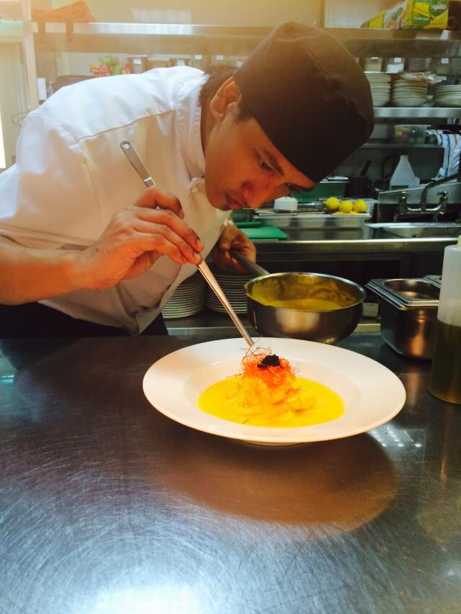

Rojie
Rojie.341765@2freemail.com

Objective:
To obtained suitable position in prestigious company where my experience will be utilized.

Committed and services oriented person ability to work in a fast-paced, high pressure environment characterized by works ethics emphasizing dedication, trustworthiness integrity and hard where initiative, analytical skill, maturity and ability to anticipate and develop effectively, timely solutionaire careers work.

Menu Specialties:
- Slavic Food
- Modern European Food
- Thai Food
- Italian Food
- Asian Food
- Japanese Food

Professional Experience:
November 2015 – Up to present Vesna Restaurant and Lounge
PPM Conrad Hotel Dubai UAE
Kitchen: Chef de Partie

Job Responsibilities:
- Responsible for all the mis-en-place in the section were I assign.
- Preparing and Cooking foods according to the standard quality and procedure of the company.
- Responsible in reporting to the Head Chef and Sous Chef regarding kitchen concerns.
- Received delivery and made proper stocking of product to their proper storage.
- Food Preparation Responsible for the cleanliness of the kitchen.
- Knows how to used kitchen equipment and can work under pressure during busy time.
- Responsible for preparing the monthly / daily inventory of all store stocks.
- Responsible for organizing the kitchen and station where I assign Perform any duties and tasks as requested or as may be necessary, by the head chef or the management. Apply the FIFO method all the time Ensure the smooth preparation and service to company’s standard’s procedure of all foods items.
- Responsible for Tasting the Food before sending Applying L- look S- smell T- taste at all the times Handling Pass Section if the Head Chef Or Assistant Chef is unavailable.
- Responsible for the usage of standardized recipes to quality standards Knowledgeable of Food Costing.

Professional Experience:
May 2014 – October 2015 The Farm Al Barari Restaurant
Al Barari, Dubai U.A.E.
Kitchen: Commi work as a DCDP

Job Responsibilities:
- Prepares all menu items according to quantity menus.
- Kitchen Team Leader
- Bakes, roasts, broils and fries meat, fish and fowl.
- Mixes and cooks specialty dishes and delicate foods.
- Seasons foods by taste test and recipe.
- Maintains records of food used and supply on hand.
- Figures food cost and records on daily food cost sheet.
- Cleans and sanitizes work areas.

Professional Experience:
May 2013- April 2014 The Farm Al Barari Restaurant
Al Barari, Dubai U.A.E.
Kitchen: Commi

Job Responsibilities:
- To work as directed on station of assignment under appropriate Chef de Partie.
- Set up station properly and on time for each service period.
- Make sure all food is prepared by recipes designated by the Sous Chef or Chef de Partie.
- Be able to work in another area when needed and take part in cross training when directed.
- All food items for storage must be covered, dated and labeled according to 70 point checklist.
- Follow clean as you go policy and keep work area clean at all times.
- Proper food rotation – first in – first out.
- After service switch off and clean oven tops and work areas as well as surfaces.

Professional Experience:
May 2012 – April 2013 The Farm Al Barari Restaurant
Al Barari, Dubai U.A.E.
Kitchen: Commi

Job Responsibilities:
- Prepare ingredients for cooking, including portioning, chopping, and storing food.
- Wash and peel fresh fruits and vegetables, weigh, measure and mix ingredients.
- Prepare and cook food according to recipes, quality standards, and food preparation checklist and also prepare cold foods.
- Operate ovens, stoves, grills, microwaves, and fryers.
- Test foods to determine if they had been cook sufficiently.
- Monitor food quality while preparing food and set up break down work station.
- Serve food in proper portions onto proper receptacles.
- Wash and disinfect kitchen area tables, tools, knives and equipment, check and ensure the correctness of the temperature of appliances and food.

.

Achievements / Certificates:
- Two Consecutive Times Employee of the Month (Aug & Sep 2012) – Al Barari The Farm – Dubai, UAE
- Food & Hygiene Training Level I & II Certified – Specipico, Dubai, UAE
- Food & Beverage Services NC II – Manila, Philippines
- Basic Safety Training – Manila, Philippines

Educational Attainment:
Secondary: Cayetano Arellano High School
C.M Recto Manila Philippines

Personal Skills:
- Computer Literate MS Word/Excel and Internet
- Basic Driving, Basketball, Billiard, Lettering

Personal Profile:
- Date of Birth: June 26 1982
- Place of Birth: Manila, Philippines
- Nationality: Filipino
- Gender: Male

Character Preference:

AVAILABLE UPON REQUEST

