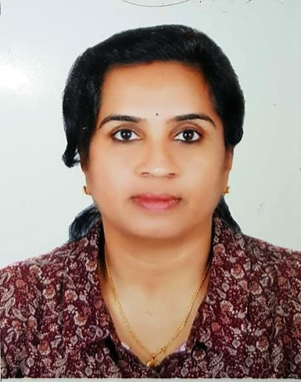

Sheeja
E-mail: sheeja.341774@2freemail.com

OBJECTIVE:

To secure a permanent or temporary position in administration or customer service at a reputed firm and thereby utilize my experience in versatile office management skills with strong interpersonal and organizational skills

CAREER PROFILE:

  - Energetic and reliable skilled at working with diverse group of people
  - 7years of rich experience gained within diversified industries within Dubai and India
  - Proven expertise in A/P, A/R, Petty cash management and reconciliation
  - Strong organization, communications and relationship building skills
  - Handled multi task on several assignments and meet strict deadlines
  - Well experienced in administration and finance.
  - Strong background in customer service. Proven ability to satisfy customers which are in need for customer support.
  - Has attended reputable seminars including Personal development and communication skills.
  - Have the ability to execute programs using limited resources. Problem Solving, leadership and communication skills are some of the qualities developed from my experiences from my previous work.

JOB EXPERIENCE:

Home tutor from 2003 till date
Proved ability in teaching all subjects from grade 1 to 10

Accounts Assistant
Silvertech, Jafza, Dubai
Nov 2000 – June 2002
- Support and backup Finance department, accountant and management team by completing routine clerical and accounting tasks.
- Petty cash managing, Purchase receivable, payable etc.
- Accounting of telephone bills and making related reports
- Providing weekly and monthly reports
- Handled a broad scope of internal process encompassing the daily management of billings, collections, reconciliation and month end closings with a main focus on accounts receivable.
- Scheduling monthly and quarterly meetings for Finance Controller
- Handled major processes in the financial department in dealings with cheque, customer payment follow ups, Cancellations, Amendments etc.

Secretary /Admin officer
GERMNISCHER LLOYD, DUBAI
June 1999 – Oct 2000
- Handling all Administration, Accounting and Secretarial works
- Responsible for handling financial transactions including invoicing, A/P and A/R
- Provided assistance to Director in letter drafting and all office dealings
- Assisted the team leader on preparing the reports, data entry of forms etc.

Secretary /Accounts Assistant
Oman Abrasives, Dubai
Dec1996 -Mar1998
- Handled the most of the administrative and secretarial works
- Handled all office correspondence utilizing my professional skill in MS Word, Excel
- Prepared daily Sales and Financial report in excel
- Assisted the Sales department in office works
- Executed all other secretarial works

Administration Executive
SONY Service, Madonna Electronics, Kerala
1995- Nov1996
- Front line dealing and direct contact with customers in Reception
- Meeting customer expectations and ensuring customer satisfaction is met
- Day to day account monitoring and monthly reporting to Head office
- Handled financial transactions including invoicing, A/P, A/R
- Checking and recording monthly inventory and stock details
- Preparing budget, maintaining reports and completing basic bookkeeping an accounting duties
- Managing and assisting technicians, allocating appointments to sales

Accounts Manager
PHIRWANSI INVESTMENTS, Kerala -1995
- Maintained and handled entire accounting transactions
- Working with spreadsheets, sales and purchase ledgers and journals
- Secretarial assistance to the Managing director
- General office administration
- Monitored the Share market rates

Accounts Assistant
Majestic Shares and Securities (P) Ltd. Kerala, 1994
- Handled all the books of accounts including Journal and Ledgers
- Corresponding with customers and dealing with their queries
- Prepared computerized accounting and share market reports
- Graphed the Market fluctuations and Share market rates

Secretary
HI WINGS TRAVELS (P) Ltd. Chennai,
1993 to 1994
- Support and back-up Admin and Accounts
- Monitored day to day accounting and admin works
- Ticket booking and handling Travel queries
- Prepared travel affidavits and maintain vital documents including Passport

SKILLS

- Computer-S Office, MS Word,Excel, Power point- Expert -more than 15 year experience
- Data entry – 45 w.p.m. and Shorthand writing – 30 w.p.m.
- Having great Organizing and accounting skills
- Overall responsibility for organizing party, games, get together etc.
- Time management skills

EDUCATION AND DIPLOMA

B.Com graduate from Ethiraj College, Chennai Year 90-93 with 65%
96% in H.S. exam (Accounts, Maths) from S.J.S. Matriculation, Chennai, Year 88-90
84% in other subjects (attached Certificate)
  - Certified Passenger Service Agent (PSA), Blue Ocean Academy, Dubai
  - Personality development and communication skills, Dubai
  - Attended many other Seminars on personality development
  - Certified in MS Office (MS Word, MS Excel, MS PowerPoint)
  - Diploma certificate in Galileo and Tally software

PERSONAL PROFILE

Birth Date: November 28, 1972
Marital Status: Married
Visa Status: Residence visa- Husband sponsorship
Citizenship: Indian
Language Spoken: English, Hindi, Tamil, Malayalam (all fluent) and Arabic

Reference: Available on request

Interests: Internet browsing, Reading, listening to music, Art and Stitching and Interior designing.

