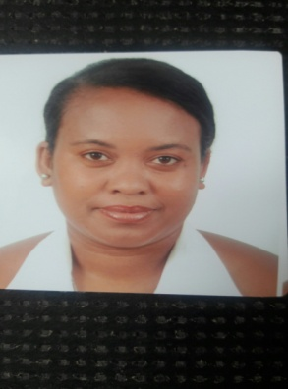
Name : Marie
Age : 29 years old
Date of birth:15 december 1987
C/o-Phone number: +971503718643
Mail address: marie.341800@2freemail.com
Nationality: Mauritian
Current work: FNB waitress
Company :Pullmantur cruise ship
Language spoken:English
French
Spanish(basic)

EDUCATION

PRIMARY SCHOOL: Sir Pierre Dalais Gov School
SECONDARY SCHOOL: Prof Basdeo Bissondoyal College

FORMATION

JR school: Front Office Foundation

Professional Experience

Infinity BPO: Selling agent(2010)
Le Shangri-La (Touessrok)Hotel : Babysitter (2009)
Lux Belle Mare : Hostess and waitress (2011)
Pullmantur cruise ship :Waitress (2013)

ì

