Curriculum vita

VISHAL 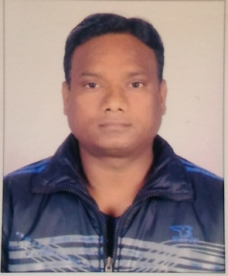
C/o-MOB NO: +971503718643
Email: vishal.341816@2freemail.com

CAREER OBJECTIVE

- To work among those leading companies who has the zeal, potential and ability to prosper by providing privilege to experience and qualified candidate who can work for the growth of the organization.
WORK EXPERIENCE
- Worked as a Purchase Executive 10 years in India

JOB RESPONSIBILITIES

- Purchase materials for construction sites form suppliers & direct from building material companies
- Quality check with the help of technical team

ACADEMIC QUALIFICATION

- B.COM
- 1 YEAR DIPLOMA IN COMPUTER

EXPERIENCE

- Two year Experience as Team Leader (DST) in CITI FINANCIAL at Jallandhar. July 2002 to Aug 2004.
Job Description: Direct sale loan through the team of 8 members, convince and motivate the team members as well as client to accept the proposal.
- Two and half years in Maruti Insurance (New India Insurance) at Hoshiarpur Autotobiles at Hoshiarpur as a Sr. Sales Executive. Sept 2004 to Feb 2007.
Job Description: New & Old Vehicle Insurance.
- Worked with Hydle Constructions Pvt. Ltd., as Purchase Executive for Uttrakhand projects. April 2007 to June 2011
Job Descriptions: Purchase building materials for construction sites from market and direct to Cement & TMT Bars Companies at good cost with the help of my company’s technical team.
- Worked with Sidhivinayak associates a Dump of Jaypee Cement at Hoshiarpur. July 2011 to Sep 2011
Job Description: Visits sites. Enter challans with company software.
- Worked with Jaiprakash Associates Limited(JayPee Cement) as Sales Representative at Ferozepur & Hoshiarpur Oct 2011 to Feb 2013
Job Description: Area representative who allow the old cement dealers to make sale as well as find new cement dealers for innovative sale. I organized small meetings for the product marketing and advertisement of Jaypee Cement and solve the cement/construction related issues.
- Former employee of Nirmaan Associates as Purchase Officer at Hoshiarpur April 2013 to 15 Jan 2017
Job Description: Purchase building materials for construction sites from market and direct to Cement & TMT Bars Companies at good cost with the help of my company’s technical team.
PERSONAL DETAILS
NATIONALITY : INDIA
DATE OF BIRTH : 15 JULY 1979
MARITAL STATUS : MARRIED
RELIGION : CHRISTIAN
VISA STATUS : VISIT VISA

LANGUAGES

- ENGLISH, HINDI, PUNJABI

HOBBIES
- Listen Songs
- Traveling in different places
- Off-roading with my Royal Enfield
- Hiking, Camping
- Surfing
PASSPORT DETAILS
DATE OF ISSUE : 05 DEC 2016
DATE OF EXPIRY : 04 DEC 2026

STRENGTH
- Hard working, quick learner, able to work under pressure and innovative.

Date: ……….. Vishal

