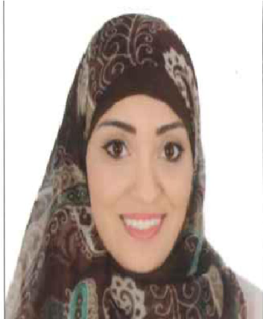
HALA
C/o-Mobile: +971501685421
E mail:hala.3418263@2freemail.com
Nationality: Egyptian.
Birth place: United Arab Emirates.(Al-Ain)
Marital Status: Married
DOB: 12 April 1988
OBJECTIVES:
A DHA certified Physical therapist seeking employment that will utilize my specialized skills and knowledge gained throughthe last five years of experience in both public and private sectorsfor the wellbeing of patients.
PERSONAL SUMMARY:
A highly motivated, confident individual with exceptional multi-tasking and organizational skills. Able to communicate effectively and sensitively with patients and care givers to maximize the rehabilitation of patients and to ensure understanding of often complex clinical issues impacting on recovery. Excellent ability to work closely with other health care professionals to assess patient needs and devise suitable treatment plans to achieve superior outcomes.
WORK HISTORY:
- Ministry Of Health From 24/9/2012 to 28/8/2016
As a Physiotherapist responsible for providing physiotherapy assessment and treatment.
Responsibilities:
- Providing a high standard of physiotherapy service to patients.
- Ensuring that equipment used in carrying out physiotherapy duties is safe.
- Evaluating, planning and delivering care plans in response to complex needs
- Implementing relevant standards and policies.
- Involved in a patients follow-up care.
- Prioritizing urgent referrals.
- Designing weight reduction and gain programs using physical training and nutritional diets.
- Tahseen Cosmetic Clinic from 1/7/2014 to 1/7/2016
As a physiotherapist responsible for the care and control of postoperative case by periodical follow ups and lymphatic drainage sessions.

- Inshape Cosmetic Clinic from 1/10/2010 to 30/11/2012
As a physiotherapist managing post liposuction cases using manual lymphatic massage and therapeutic ultrasound to:
          - Reduce edema
          - Reduce tissue fibrosis
          - Control pain
- Experimental Year from 1/11/2010 to 30/11/2011
Trained in the following specialties:
    - Orthopedic: 2 months
    - Neurology : 2 months
    - Pediatric : 2 months
    - Internal : 2 months
    - General Surgery: 2 months
    - Obstetrics &Gynecology : 2 months
EDUCATION:
DHA Eligibility letter: Valid
Post graduate Education:
- Doctor Of Physical Therapy (DPT) Class of 2016
Grade: Very Good GPA : 3.4

College Education:
- Bachelor of Physical therapy from Cairo University Class of 2010
Grade: Good (70.95%)
Courses:
- Stroke rehabilitation from Al Kasr Al-Aini teaching hospital
- Kineso Taping from the faculty of physical therapy Cairo University
- Basic Radiology organized by the Scientific Society of Radiology (Egypt)
- Sports Injury & Rehabilitation organized by GPTS (General Physical therapy Syndicate)
- Kinesiology Taping Basics & Clinical Applications from the ARES Taping Association Korea

High School:
Al- Ain Juniors School with an excellent academic performance in IGCSE.
- O level Grades: 1 A*, 6 A, 1 B
- AS level Grades: 3 B
- A level Grades: 1 C

KEY SKILLS AND COMPETENCIES:
- Good time management
- The ability to build a rapport with patients from a variety of backgrounds and communicate with their relatives and care givers.
- Tolerance and patience
- Interpersonal skills
- Team working skills

