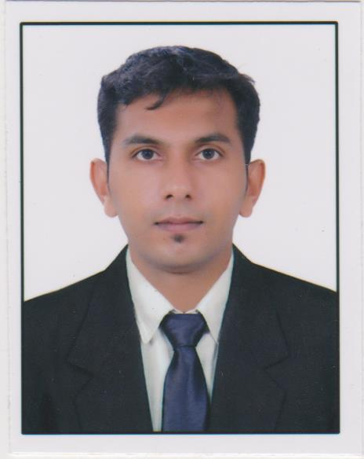

SUBIN

C/o-Phone: +971 504973598 E-Mail: subin.3415859@2freemail.com

OBJECTIVES

To be associated with a progressive organization which can provide me with a dynamic work sphere to extract my inherent skills as a professional, use and develop my aptitude to further the organization’s objectives and also attain my career targets in the progress.

EDUCATIONAL QUALIFICATION

Qualification | Board/University | Year
B.COM(Computer Application) | Kerala University | 2012
XII | Kerala Secondary School Certificate Examination | 2009
X | All India Secondary School Examination | 2007

WORK EXPERIENCE (Total – 3.3 years)

November 2012 – July 2014,Branch Head(officer) for
MANAPPURAM FINANCE LTD, Delhi, India.

- Branch operations & Customer relationship
- Assist and support the area manager in operating the branch functions.
- To take part actively in the meetings regarding sanctioning of Gold loans, Money transfer,forex and other financial decisions of the company.
- Facilitate regular employee meetings to discuss goals, operational issues etc.
- Take care of the customers so has to help and solve customer concerns and queries.
- Ensuring there is a high level of customer service.
- Managing difficult situations with customer and providing them with a resolution, additional options.
- Perform as team member in allocating and coordinating the work flow.
- Comply with all department and company policies, procedures and regulation.
- Develop and grow business and customer relationship.

- Strong communication, analytical, problem solving and decision making skills to effectively uncover and resolve complex customer and employee issues.
- Motivate the employees after evaluating their performance.
- Self-starter, ability to work independently.
- Handling the role and responsibility of absent employee
- Inventory management
- Encoding subordinates

January 2015 – March 2016,Marketing Manager for
NOBLE ASSOCIATES, Trivandrum, Kerala, India.

- Marketing and Customer relationship
- Developing the marketing strategy for the company in line with company objectives.
- Co-ordinating marketing campaigns with sales activities.
- Planning and implementing promotional campaigns.
- Preparing online and print marketing campaigns.
- Working closely with design agencies and assisting with new product launches.
- Preparing online and print marketing campaigns
- Analyze market trends and recommend changes to marketing and business development strategies based on analysis and feedback

June 2016 – November 2016, Store Sales Executive (Retail) for
DHL EXPRESS INDIA PVT. LTD, Cochin, Kerala, India.

- Branch operations & Customer relationship
- Assist and support the Cluster Relationship manager in operating the branch functions.
- Introducing new corporate products or service to established clients.
- Ensure documents are delivered and entered accurately.
- Arranging pick up as per the scheduled pick up timings of collection executives.
- Tracking and routing the shipments
- Accept cash from customer and generate cash receipt.
- Coordinate of incoming and outgoing mail.
- Communicate about the status of shipment to the customers.
- Ensure highly secured packing of materials.
- Ensuring packages are pack correctly and taking precautions with fragile packing’s.
- Doing security acceptance and security inspections of materials in POS.
- Ensuring there is a high level of customer service.
- Perform as team member in allocating and coordinating the work flow.
- Develop and grow business and customer relationship.
- Self-starter, ability to work independently.
- Handling the role and responsibility of absent employee.

TECHNICAL CERTIFICATIONS

- Special Training attended for UAE shipping and Freight Forwarding Procedures and Familiar with EMIRSAL 2 declaration processing.
- Diploma in Logistics and Supply Chain Management (& Freight forwarding) - Mithra Institute of Management Studies (MIMS) /STED COUNCIL-Govt of India– ISO 9001:2008 Certified – INDIA 2014
- Diploma in Computer Application (DCA)

PERSONAL STRENGTH

- Good leadership quality.

- Optimistic attitude.
- Good communication skills and listening skills.
- Hard Working, Enthusiastic, Willing to change & Cooperative.
- Holder of valid Indian Driving Licence.

COMPUTER PROFICIENCY

- Basic Computer knowledge, Basics of C & DCA

- MS. OFFICE

PERSONAL PROFILE

Date of Birth - 21st April 1991

Sex - Male
Nationality - Indian

Languages known - English, Hindi, Malayalam
Marital Status - Unmarried

I hereby declare that the information given herewith is correct to my knowledge and I will be responsible for any discrepancy.

SUBIN

