Contact HR Consultant for CV No: 2051160
E-mail: response@gulfjobseekers.com
Website: http://www.gulfjobseeker.com/employer/cvdatabasepaid.php

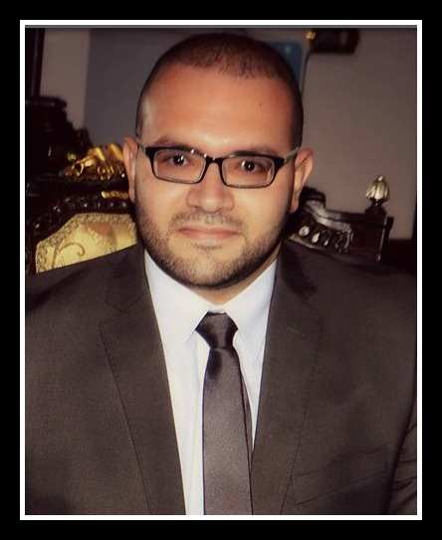

Objective Looking for a challenging and rewarding position
In a reputable company where my educational
Background and experience could be developed, and
Provide me with versatile and challenging responsibilities.

Personal Information  Experience | - Date of Birth: 24th of March 1986.  • Place Of Birth: Cairo.  • Nationality : Egyptian.  • Marital Status: Married.  Since August 2010 - Present  Customer Service Representative in Sales& Retention Section, Ajman Customer Care Center, Etisalat, UAE  - Corporate Sales Team Member. Promotes, Sells and Secures orders to existing and potential corporate customers through a relationship-based approach, and assist them in selecting those best suited to their needs.  Responsible for selling and Retaining Corporate accounts, besides handling all their needs related to corporate products through Outgoing calls  Support and provide superior service via phones, e-mails and faxes as a receiver and caller.  Apply the proper telephone etiquette to handle and satisfy various customer situations.  Responsible for achieving sales target of most of Etisalat products.  Responsible for retention target of most of Etisalat products.  Display Time flexibility towards shifts as per work requirements and business need.  Other Duties as assigned.  February – August 2010  Customer Service Representative in H.D Bank, Cairo, Egypt  • Tele Sales.  • Handling Customers situations.  • Retail Banking.  • Personal Loans.  • Auto Loans.  - Real Estate Loans.  June 2008 – December 2009  Customer Service Representative in Mobinil Egypt  ▪ Receiving Inbound Calls.   ▪ Direct Outbound Calls.  ▪ Saving customer data.  ▪ Working on Siebel and IN applications.
Under Graduate  General Training. | During Summer of 2007  General Training in Al Ahly Egyptian Bank, El Nozha Branch, Cairo, Egypt  ▪ Accounting.  ▪ Public Relations.  ▪ Dealing with customers.  ▪ Processing LCs and LGs.  ▪ Opening accounts, issuance of Master & ATM Cards.  ▪ Processing of Car Loans and personal loans.
Education | Bachelor of Commerce in 2009, Accounting  Ain Shams University, Cairo, Egypt.
Language Skills | ▪ Arabic: Mother Tongue.  ▪ English: Fluent spoken & written  ▪ Deutsch: Fair.
Computer Skills | ▪ Proficient user of MS Word, Excel, and PowerPoint  ▪ Proficient user of Internet.
Interests | Reading, Travelling, Ridding Horses, Listening to Classic Music.
Personal Qualifications | ▪ Ability to work hard under pressure.  ▪ Alert and able to handle critical situations.  ▪ Dynamic, creative and self motivated.  ▪ Fast Learning and good communication skills.  ▪ Work individually and as cooperative team member or leader.

