Contact HR Consultant for CV No: 2051274
E-mail: response@gulfjobseekers.com
Website: http://www.gulfjobseeker.com/employer/cvdatabasepaid.php
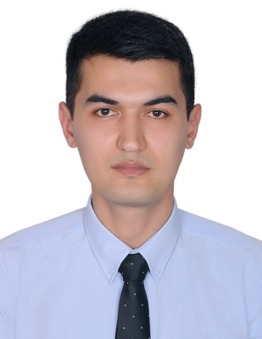

Position applied for: Sales Executive
Visa status: Employment Visa (Contract Ended)
CAREER OBJECTIVES

PERSONAL PROFILE

Date of birth 18 July 1987
Gender Male
Marital status Single
Nationality Uzbek
Total experience: more than 6 years
GCC experience: 2 years

INTERPERSONAL SKILLS

- Able to perform confidently, courageous and liable.
- Excellent relationship builder.
- Responsive and attentive through focusing 100% on clients and their result.

LINGUISTIC SKILLS

- English - Fluent
- Russian - Fluent
- Uzbek - Native
- Turkish - Good

Seeking a position as Sales Executive in an organization where there is an opportunity to exhibit my strength and enhance skills by utilizing and dedicating myself as a resource for all kinds of challenging duties assigned by the company and striving for the growth, development and success of the company.

WORK EXPERIENCE
Position: CASHIER
Organization: Italian restaurant “Margherita” Dubai, UAE
Period: February 2015 – February 14, 2017 (Contract ended)

Job description:
- Take customer orders at the counter
- Receive payments and present change to customers
- Function as the host of the restaurant
- Make reservations for customers
- Receive food checks from waiters or customers
- Appeal to impatient or irritated customers, especially during rush hours
- Manage the register, including all credit card and cash operations
- Ensure a balance of the register at the end of the shift or working period
Position: SALES EXECUTIVE
Organization: Retail store “New Millennium” Tashkent, Uzbekistan
Period: June 2012 – October 2014

Job description:
- Ensuring high levels of customer satisfaction through excellent sales service.
- Assessing customers need and providing assistance and information on product features.
- “Go the extra mile” to drive sales.
- Maintaining in-stock and presentable condition assigned areas.
- Actively seeking out customers in the store.
- Remaining knowledgeable on products offered and discussing available options.
- Cross selling products.
- Team up with co-workers to ensuring proper customer service.
- Building productive trust relationships with customers.

KEY SKILLS
- Ability to communicate effectively with a wide range of customers.
- Proven aptitude for dealing with customer complaints.
- Extensive knowledge of Microsoft Office and Excel.
- A clear and confident telephone manner.
- Experience of working in a busy environment.
- Dealing with customers Face to Face.
- Prospecting for sales leads.
- Able to identify and act upon potential sales opportunities.

Position: SALES EXECUTIVE
Organization: International trading company “Europe Exclusive”
Tashkent, Uzbekistan
Period: February 2010 – May 2012

Job description:
- Listening to customer requirements and presenting appropriately to make a sale.
- Maintaining and developing relationships with existing customers in person and via telephone calls and emails.
- Cold calling to arrange meetings with potential customers to prospect for new business.
- Acting as a contact between a company and existing and potential markets.
- Negotiating the terms of an agreement and closing sales.
- Gathering market and customer information.
- Representing their company at trade exhibitions, events and demonstrations.
- Negotiating on price, costs, delivery and specifications with buyers and managers.

ACADEMIC QUALIFICATION

Institution: Engineering College in Tashkent, Uzbekistan
Period: September 2002 – June 2005

ACHIEVEMENTS
ACHIEVEMENTS
- “Employment of the Month” certificate from the restaurant “Margherita” in January 2017.
- The certificate of IELTS “6.0 band score”
- The certificate of English proficiency
- The certificate of best essay writer

REFERENCES
Available on request

