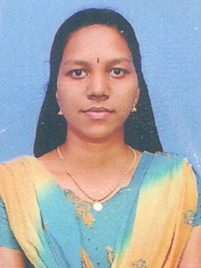
ANISHA
C/o-MOBILE NO. +971501685421
Email : anisha.341913@2freemail.com

APPLIED FOR THE POST OF

DENTAL ASSISTANT NURSE

OBJECTIVE

To obtain a challenging position that will utilize my knowledge & interpersonal skills while leading to opportunities for advancement, professional growth and to prove my existing abilities as an asset.

PERSONAL DETAILS

Nationality : Indian
Date of Birth : 10/07/1989
Gender : Female
Marital Status : Married
Visa Status : Job Visa

ACADEMIC QUALIFICATION

- Higher Secondary Certificate 2006
St. Mary’s HSS Melpala Tamil Nadu

- Secondary School certificate 2004
St. Mary’s HSS Melpala Tamil Nadu

PROFESSIONAL QUALIFICATION

- DHA ASSISTANT NURSE 2014
Dubai Health Authority

- Professional Registration 2010-2013
Andra Pradesh Kerala Nursing Council

- General Nursing & Midwife 2010
Mary Matha School of Nursing Kurnool

LANGUAGES KNOWN

- English, Hindi, Malayalam

PROFESSIONAL SKILLS

- 2 Years 7 month experience as a registered nurse.
- Good communication & interpersonal relationship.
- Excellent management power in emergency situations
- Serve as a professional role model, teacher & resource person
- Demonstrate initiative in the performance of duties
- Good team leading capacity
- Can adjust with any situations and handle it skillfully

WORKING EXPERIENCE

Name of Hospital | Experience | Bed Capacity | Period
Medanta The Medicity | 2 Years 7 month | 1092 | 01/08/2011-31/03/2014

PRESENT WORKING

JUPITER AL QUSAIS POLYCLINIC FROM 01-12-2014 TO TILL CONTINUE IN DENTAL DEPARTMENT

NURSINGCARE AND MANAGEMENT

- Giving medication and injection to the patients
- CPR Procedures
- IV Cannula insertion and infusion of Fluids
- Catheterization
- Endotracheal suction and oral suction
- Tracheostomy Care
- Insertion and removal of ICD procedures
- Insertion and removal of line
- Maintaining TPR & IO Charts
- Nasogastric tube insertion and feeding
- Help in promotion of mental & physical health of the patients
- Assisting patients to meet their personal needs
- Monitoring SPO2 and Cardiac Output
- Providing adequate nursing care
- Administering prescribed medicines to the patients
- Accompany the doctors on rounds
- Admission & discharge procedures
- Administration of Blood & Blood products
- Intubation &Extubation
- Removal of sutures

DECLARATION

I hereby declare that the above said particulars are true to the best of my knowledge and belief.

REFERENCES

References will be furnished on request.

