CURRICULUM VITAE

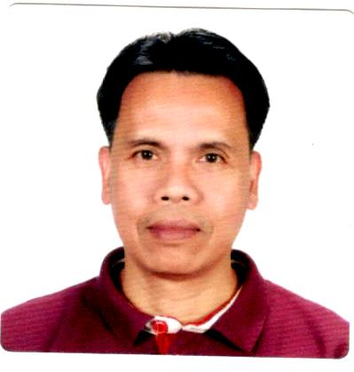

RONNIE
Email: Ronnie.341927@2freemail.com
C/o-Mobile #: +971503718643

CAREER OBJECTIVE

A motivated, result-oriented applicant, seeking an opportunity to utilize expertise, skills, and education and to contribute my knowledge and experienced this field.
KEY EXPERIENCES

Rich GCC experienced in Warehousing / Storekeeping,/ Inventory / Timekeeping / Document Control.

EDUCATIONAL BACKGROUND

Diploma in Electronic Broadcast Technician - Graduated 1990
Diploma in General Radio Communication Operator- Graduated 1989

School: Philippine Electronic & Communication Institute
Butuan City, Philippines

Short Courses:
Welding- SMAW
Refrigeration & Airconditioning
Massage Therapy ( NCII Certified)

WORK EXPERIENCED

Mesopotamia General Contracting Company April 2015 – Present Doha, Qatar
Storekeeper/Timekeeper / Document Controller

Implemented & standardized HR policies and procedures across the working sites.
Be the source of reference for employer and employee on HR Manual & Qatar Labor Law and ensuring compliance with them
Oversee exempt and non-exempt timekeeping processes for the entire department.
Receive a written or electronic account of all hours worked.
Obtain supporting documentation for all leave usage.
Ensure time and attendance records for every employees are submitted within established deadlines for payroll processing.
Prepare and validate corrected timesheets.
Review and sign off on timecards submitted by supervisors in their designated areas.
Process manual or electronic timekeeping actions.
Update the unpaid leaves on HRMS.
Provide the overtime summary to HR Department for payroll processing.
Act as liaison between the HR department and other departments for attendance.
Ensuring data is backed up at the end of every working day
Provide effective administrative support to the administration Manager

Amtaar Investment Company May 2013- 2014 Khartoum, Sudan
Warehouse – In Charge / Storekeeper

In charge of receiving and issuing all agricultural supplies, such as Fertilizers, Seeds,Insecticide Agricultural machine spare parts in the warehouse.
Submission of daily report of diesel consumption, agricultural supplies and spare parts.
Re-ordering of materials those below minimum stock for replenishment.

Samama Contracting Company Sept. 2009 – Sept. 2Riyadh, KSA
Inventory Specialist

Controlling all asset transfer & reviewing clearances those who will go vacation and exits. If cleared clearance will be sign.
Checking and verifying all invoices to the receiver by phone and emails.
Reviewing PR, PO, against Invoices and Received Notes to find out descrepancies.
Submission of monthly reports of Good Received, Issued and Balance to Finance Dept.
Regular visit on site for random physical inventory check of equipments and materials.

Southern Can Making Company June 1996 - June 2002 Jeddah,KSA
Sept. 2002- Feb. 2008Jeddah, KSA
Storekeeper

In charge of receiving, issuing of all materials needed in the production line.
Re-ordering of materials and machine parts those below minimum stock level for replenishment.
Data entry of in-coming and out going of materials and machine parts.
Coordinates with shift Supervisors regarding spare parts order and repairs.
Operate Forklift if necessary.
Keeping the stores clean and tidy at all time.

Diamond Haus Corporation 1992- 1995 Manila, Philippines
Machine Operator

Operates and maintained Powder Coating Spray Machine.
Powder Painting of Steel Furnitures ( Steel Beds )

PEC Broadcasting Corporation ( TV5/ DXGL- FM Station) Butuan City, Philippines

Studio Technician

Prepare program schedules.
Set up control& operate radio transmitter and associated audio/ video equipments in the station.
Coordinating with onboard announcer during his/her time as master controller.
Monitors and play recorded commercials as per daily airtime schedule.
Regular checking of voltage and amphere of the transmitter and log readings.
Preview schedule program to ensure that the signal are functioning and programs are ready for transmission.
Maintain program logs as required by station management & NTC.
Substituting other programs in cases where signal fails.
Coordinating public and private video coverage for local news coverage.
Video recording and editing.

INTERPERSONAL SKILLS

- Effective interaction with individuals at all levels of the organization.
- Self- motivated can work independently, with team support
- Organized and dedicated with a positive attitude.
PERSONAL DETAILS
Nationality | Filipino
D.O.B | 10November 1966
Marital Status | Married

Employment Certificates / References are available upon request.

I certify that the above information is true and correct to the best of my knowledge and belief.

Sincerely,

