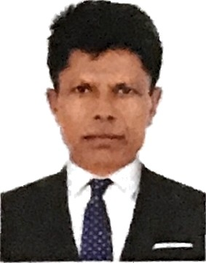

JITUBHAI
DUBAI — UAE

Seeking for substantial responsibility w here my past and varied experience would be
Fully utilized in a career opportunity and where making a significant contribution to the success of my

employer which will gain me a career advancement opportunity.
Work Experience

• Worked as a Sales Executive in a Marble & Natural Stone Trading Company based in Dubai (January 2018 — Till date)
• Worked as a Driver at Kamprave FZE in Dubai (4 year)
• Worked as a Sales Executive and Driver at Vista Marble & Natural Stone Trading LLC in Dubai (4 year)
Job Skill

* Excellent skill in Dri› ing and Delivery
* Good Co-operation with all nationalities
* Problem solver with good common sense * S incere and Hard worker
EDUCATIONAL QUALIFICATION
9TH Passed

PEPSORALDETAILS

Date of Birth Nationality Passport No Issue Date Expiry Date Visa Status
LICENSE DETAILS

License

English Hindi Gujarati

01/06/1972
Indian S8761049 16/08/2018
15/08/2028

Visit Visa

(Light Vehicle,)

Contact Details:
Contact Email : jitubhai-34098@2freemail.com
Reference : Mr. Anup P Bhatia, Market Research HR & IT Consultant
Mobile No. :+971504973598

In the view of the above particulars, please consider this application and give me an opportunity in your esteemed organization. I assure that I would carry out my duties to your entire satisfaction.

JITUBHAI

