CURRICULUM VITAE
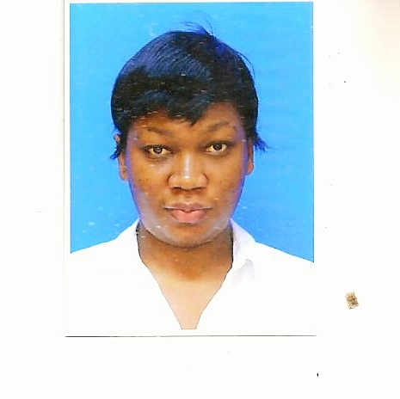
Faith
Email: faith.35428@2freemail.com
Bio Data | Gender: Female  Date of Birth: 1989  Nationality: Kenyan
Personal Profile | I am a result-driven professional with a progressive career. I have exceptional multi-tasking capabilities and able to work in a target driven, busy cell center environment. I am a service orientated professional who is very confident when handling enquiries, complaints, and communications. I am also able to work to timely demands and effectively manage multiple workloads. I desire to be part of an organization that provides unlimited utilization of my academic, interpersonal, organizational, and communication skills in pursuit of effectiveness, efficiency, and promotion of quality in dissemination of my assignments.

Education& Certificates | 2011 - 2014 Bachelors in International Business Management  Asia Pacific University, TPM, Bukit Jalil, Kuala Lumpur, Malaysia (CGPA)  2008 - 2010 Certificate Foundation in Media studies  Curtin University of Technology Sarawak, Miri, Malaysia  2004 - 2007 Kenya Certificate of Secondary Education  Gatanga Girl’s Secondary School  1997 – 2003 Kenya Certificate of Primary Education Lugulu Boarding Primary School  July 2016 Training Certificate by Digify Africa Digital Marketing

Skills | - Customer and Personal Service: Knowledge of principles and processes for providing customer and personal services. This includes customer needs assessment, meeting quality standards for services, and evaluation of customer satisfaction  - Relationship Management: I am a proven relationship builder with excellent interpersonal skills and I am able to nurture and retain strong relationships with existing and new customers  - Interpersonal and communication skills: I am able to build an understanding of the client needs and concerns, and express these to other members of my team  - Flexibility and Adaptability: I am a flexible team player who thrives in environments that require ability to effectively prioritize and juggle multiple concurrent tasks. I am also very positive, detail oriented, resilient and open to new ideas  - Planning and Organizing: Refined planning and organizational skills that balance work, team support and ad-hoc responsibilities in a timely and professional manner  - ICT Competence: Good command of Microsoft Word, Microsoft Excel,Publisher, Outlook ,Access, and Microsoft PowerPoint  - Language knowledge: Outstanding appreciation of the English and Swahili dialects
Work Experience | September2015 –June 2016 Sapiri Building Contractors, Kenya  Position: Secretary/Receptionist  Responsibilities:  - Responsible for storing, Maintaining and retrieving, effective records and administration i.e. keeping up-to-date contact details,compiling lists of names and addresses useful to the company  - Upholding legal requirements which include; ensuring compliance with by-laws and corporate charters, acting as custodian of the organizations governing documents, sitting on appraisal, recruitment and disciplinary panels as required  - To ensure that business of the company is conducted in accordance with its objects as contained in its memorandum of association  - Direct customers and relay goods in stock for purchase while also maintaining neat and presentable look around the front office desk  July 2014 - April 2015 SingTel Group, Malaysia  Position: Call Center Agent/ customerservice representative  Responsibilities:  - Liaise with people from both internal and external organizations.  - Ensure knowledge and familiarity with company policies and procedures to provide sound and appropriate relies to queries.  - Attending to customers’ needs, registering customer’s claims and handling the claims while registering them on the complaint book.  - Responsible for screening telephone calls, enquiries and re-directing calls as appropriate as well as taking and relaying messages as needed.  - Processed and ensured timely dispatch of membership cards to clients and intermediaries as needed

Additional Information | Positions of Responsibility  - Leader/captain in Futsal Female Club.  - Teamleaderin various group courseworkassignments  - Classrepresentative (University), memberof Kenya ScoutsAssociationandGeographyclub (highschool)  Hobbies and Interests  - Socializing  - Reading Novels  - Travelling  - Watching documentaries

