PERSONAL INFORMATION

Sayazhan
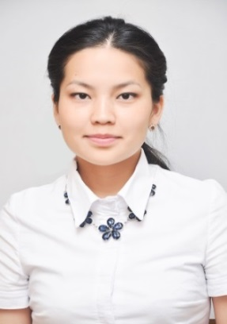

- +971501685421

sayazhan.342075@2freemail.com

SexFemale| Date of birth16/04/1992| NationalityKazakh

JOB APPLIED FOR
POSITIONProject engineer assistant

WORK EXPERIENCE _________________________________________________________

15.10.2016 – present timesEnglish teacher
Solution Language Center, Astana
- Give lessons for students of all levels, also prepare them for international exams such as IELTS and TOEFL

30.04.2016-19.09.2016Receptionist
Abu – Dhabi Plaza Project, Astana
- Working in a team, providing a quality service to customers, and dealing tactfully with complaints.

15.01.2016 – 15.03.2016Barista
Reggi’s Cafe, New York City
- Dealing with the people, taking orders

02.05.2015 - 10.07.2015Project engineer’s assistant
Khalyk Gas Service, JCS, Almaty
- Planning gas pipelines in Talgar city, making calculations of gas pipelines and storages

10.06.2014 – 25.06. 2015Translator
Ansab Group, JCS, Astana
- Translating documents from English to Russian or vice verse, participating in meetings with international partners

11.06.2013 – 20.02.2014 Receptionist – cashier
Rahat Palace Hotel, Almaty
- Planning, organization, coordination and commitment e.g., in retail, this ensured daily sales targets were met, a fair distribution of tasks and effective communication amongst all staff members.

EDUCATION AND TRAINING______________________________________________________

01.09.2010 -05.06.2014Construction of oil and gas pipelines and storages (BSc degree)
Kazakh national technical university after K.I.Satpayev, Almaty
- GPA - 3.87

20.01.2013-20.02.2013 Trainee
KazTransOil research center, Almaty
- Participated in project called “Reconstruction of oil storage in Pavlodar”

20.07.2015 – 15.01.2016 ESL courses and Business English
Zoni language centers, Flushing, New York
- Advanced low proficiency

PERSONAL SKILLS __________________________________________________________

Mother tongue Kazakh

Other languages Russian – Proficient user, English –Independent user, Spanish –Basic user

Communication skillsgood communication skills gained through my experience as receptionist

Organisational skillsleadership (currently responsible for a team of 10 people)

Job-related skillsanalytical and problem solving skills, independent user of AutoCAD,

Digital competence Proficient user
- PhotoShop
- CorelDraw

ADDITIONAL INFORMATION_________________________________________________________

Hobbies Football - member of local football team
Reading – prefer English classical literature, also science fiction books
Conferences 3rd place at the 29th students scientific conference named “The Earth is our home”; KazNU after Al-Farabi, 2014, Almaty

ANNEXES ___________________________________________________________________________
- copies of degree and qualifications;
- reference letters
- publications and diplomas

