Veera.342131@2freemail.com
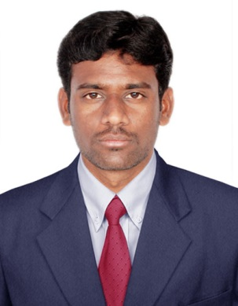

Veera

Professional Objective:
A Professional carrier in the field of Engineering where innovation and execution is the motto I am looking for. I should be able to develop myself and the company in the ever-changing technological world.
Professional Experience :
As Site Engineer (1year) Eden Interiors (P) Ltd
Chennai International Airport
As Site Engineer (3 months) Bindarif Oil and Gas Construction. Abu Dhabi (UAE)
- Execute the work as per drawing and standards both discipline.
- Coordination with consultant & project manager regarding works and inspection.
- Preparation of Estimation & Subcontractor bills.
- Preparation of daily Reports.

Academic Profile:
- B.E (Civil Engineering) SACS MAVMM Engineering College at ANNA UNIVERSITY CHENNAI in 2014, (INDIA).
- SSHN Higher Secondary School, Muhavur in 2010.
- SSHN Higher Secondary School, Muhavur in 2008.
Computer Application:
- Master Diploma in Building Design from CADD Centre, Tallakulam Nagar, Madurai.
  - AutoCAD 2D.
  - Revit Architecture.
  - STAAD Pro.
  - MSP.
  - PPM Projects.
Project Details:
Main Project:
Project Title: Bamboo Reinforcement Roof.
Scope:
Instead of steel we have used bamboo reinforcement to reduce the economics of the building.
Description:
Bamboo is a natural Functionally Graded Material (FGM). It is a composite with hierarchical structure. The strength of bamboo is greater than most of the timber products. Since this study aims at using bamboo as reinforcement for concrete beams and roof, the bamboo samples were waterproofed in order to be consistent with the reinforcement preparation.

Mini Project:
Project Title: Earthquake Resistance Of Building
Co-Curricular Activities:
- Participated in the one day national level workshop on “MODERN CONSTRUCTION TECHNIQUES AND CHALLENGES THROUGH NANO–TECHNOLOGY” at Anna University College of Engineering –Dindigul.
- Participated in the National Level One Day Workshop on “RECENT TRENDS IN CONSTRUCTION” in Sree Sowdambika College of Engineering - Arupukottai.
Area of Interest:
- Site Engineer
- Design
Declaration:
I here declare that above details are true and complete to the best of my knowledge and

