Contact HR Consultant for CV No: 2052822
E-mail: response@gulfjobseekers.com
Website: http://www.gulfjobseeker.com/employer/cvdatabasepaid.php
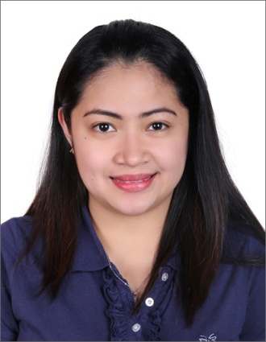

I have over 8 of experience in the field of medical technology with an excellent academic background and was a consistent Dean’s Lister during my college years. My qualifications as a Medical Technologist include Professional Regulation Commission (Philippines) with a license number 53498, credited as an International Medical Laboratory Scientist under American Society of Clinical Pathologist(ASCPi), and recognized by Health Authority Abu Dhabi (HAAD) with license number GT17720.
During my career, I was able to grow professionally by continually honing my skills through various seminars and trainings, garnering excellent laboratory skills and was highly commended by my past and present employers.
Academic Background
Education
Degree in Medical Technology, Saint Louis University, Baguio City, Philippines, Dean’s Lister
Registrations
- PRC
- ASCP
- HAAD

Certifications
- Professional Regulations Commission, Philippines, 2008
- American Society of Clinical Pathologist, 2014
- Basic Life Support, American Health Association, Abu Dhabi, November 2016
- Health Authority Abu Dhabi, April 2015, valid until April 2017
Obtained Bachelor’s Degree in Medical Technology from Saint Louis university in Baguio City, April 2008 (Dean’s Lister).
Professional Profile
- Eight years of experience as Medical Laboratory Technologist
- Handles different automated machines
- Assigned in different sections of laboratory ( Phlebotomy, Hematology, Chemistry, Serology and Immunology, Clinical Microscopy, and Microbiology Sections
- Performed samples for CAP Proficiency Testing (Hematology, Microbiology & Clinical Microscopy)
- Evaluated quality control within laboratory using standard laboratory test and measurement controls, and maintained compliance with CAP, JCI and OSHA safety and risk-management guidelines
- Has experience on CAP, ISO and JCI inspection
- Creates good working relationships with colleagues and other health professionals
- Provide extensive volunteer clinician services for private clinics and outreach programs
- Capable of doing multitasking and flexible to laboratory works
- Rendering phlebotomy services on various medical centers assigned to.

Work Experience
Al Borg Medical Laboratories, Abu Dhabi, UAE
October 2014 to Present
Al Borg Medical Laboratories, Jeddah/ Khamis Mushayt, K.S.A.
September 2011 to October 2013
Dagupan Doctors Villaflor Memorial Hospital, Dagupan City, Philippines
October 2008 to August 2011

Baguio General Hospital, Baguio City, Philippines
May 2007 to November 2007
Internship Training
Saint Louis University Clinical Laboratories
November 2006 to May 2007
Internship Training
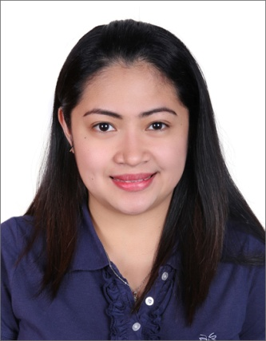
Scope Of Professional Practice

HEMATOLOGY: - Perform cell counts (i.e.) CBC, Reticulocyte counts, procedures to detect abnormalities in hemostasis (bleeding time, coagulation, clotting time), LE Cell preparation, ESR Determination, LAP SCORE and Cell counts of other body fluids.
- Expert operator on the following machines for hematology:
Education
Degree in Medical Technology, Saint Louis University, Baguio City, Philippines, Dean’s Lister
Registrations
- PRC
- ASCP
- HAAD

Certifications
- Professional Regulations Commission, Philippines, 2008
- American Society of Clinical Pathologist, 2014
- Basic Life Support, American Health Association, Abu Dhabi, November 2016
- Health Authority Abu Dhabi, April 2015, valid until April 2017
CellDyn Ruby, DiaClon by Bio Rad, Sysmex ((XE2100, XT1800).

CLINICAL MICROSCOPY: Performs urinalysis, fecalysis, semen analysis, occult blood, H. pylori.
-Expert in Operating IQ200 Elite & IChem Velocity by Iris for urine analysis.

CLINICAL CHEMISTRY and IMMUNOLOGY: - Perform blood chemistry analysis and examination, kidney function test, liver function test, enzyme determination, blood gas determination, performs electrolyte determination, 24-hour urine collection for blood chemistry testing.
-Perform thyroid panel, tumor markers, hepatitis panel analysis
-Expert operator on the following machines for blood chemistry analysis:
Architect i2000, Architect ci400, Alegria, Architect I1000SR Cobas E411, and Cobas Integra 400plus for Special Chemistry / Immunology assays. Vitros 250 Chemwel

CLINICAL MICROBIOLOGY:- Perform Gram staining, AFB staining, Culture and Sensitivity Testing of different samples, Perform API, and Streptococcus grouping, Vaginal Parasite Identification and perform Autoclaving procedure.

SEROLOGY AND BLOOD BANKING:- Performs blood typing tests (forward and reverse), Rh Typing, Coomb’s Crossmatching, Coomb’s Test (direct and indirect), compatibility testing.
- Perform blood donor screening for HIV, HCV, HBsAg, RPR/VDRL, and Malarial Smear.
- Perform other serologic procedures such as ANA Test (Anti-nuclear Antibodies), ASO (Anti-Streptolysin O Antibodies, quantitative and qualitative method), RA Test for detection of rheumatoid factor, Infectious Mononucleosis, TPHA

