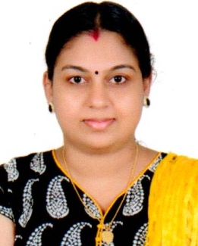
SRUTHY
E-mail: sruthy.342138@2freemail.com

Objective
Accomplished, achievement-driven and results-oriented individual. I believe that passion compensates for many shortcomings, because passion leads to diligence, and diligent perseverance can overcome any obstacle. Seeking the position of a Biology teacher in an organization that will give me the opportunity to utilize my skill set for the progress of the organization.
Skills
- Ability to work with children of different aptitude and skills.
- Excellent communication skills and ability to mix with children effortlessly.
- Ability to create an effective teaching method for the children.
- Ability to handle the behavior of children of 5 to 16 years and research skills.
- Highly skilled in using the various tools to make the teaching interesting and effective i.e. books, music and games.
- Ability to interact with the children effectively so they can learn quickly i.e. rhyming games, storytelling, etc.
- Ability to motivate the children, so that they will consider themselves a special personality.
Responsibilities
- Inspiring the students to learn the new things and shaping their future according to their interest.
- Interacting with each student and helping them solve their problems
- Arranging meetings with parents and discussing the development of the children.
- Conducting dance shows, fancy dress competition and decorating class according to various themes.
- Developing various aspects of children i.e. physical, emotional, mental, and social by allowing them to learn them according to their creativity.
- Organizing the students in the group so they can interact with each other and socialize.

Educational Qualifications
- PursuingMSc Madurai Kamaraj University
- B.Ed. Natural Science Kerala University 2014-2015 (73 % )\
- HDC FROM Co -operative College, Cherthala
- BSc Zoology from Kerala University 2003-2006 (63%)
- Senior Secondary from Boardof Higher Secondary 2001-2003 (66%).
Work Experience
- Worked in Sreenagaraja English medium school vetticode,Kerala for the post of
Teacher – 2 year( 2011-2014 )

Personal Details
Date of Birth : 11.03.1986
Languageproficiency : English, Hindi, Malayalam
Nationality : Indian
Marital Status : Married
Passport Details
Valid Passport : Yes
Date of issue : 22.10.2008
Date of exp : 21.10.2018
Interests & Hobbies : Travelling, Reading, Listening to music,
Cooking and Social Networking

Declaration
I hereby declare that the above furnished details given by me are true to the best of my knowledge and can being support by relevant certificates and documents

Thank You & Regards,
SRUTHY

