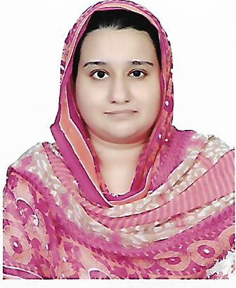
C/o-Cell Number: +971504973598
Email Address: saher.342147@2freemail.com
Address: Abu Dhabi

SAHER
Accounts Professional
Career OBJECTIVES  CORE COMPETENCIES |  |  | To secure a position in a dynamic and progressive organization that offers versatile opportunities for comprehensive career building, growth and skill development in a challenging and innovative environment with an objective to constructively contribute towards the goals of the organization and to proficiently apply my knowledge, skills and abilities which I have gained through my education  - Communication Skills - Dedication - Financial Accounting  - Acute eye to detail - Accountability - Advance Excel  - Time Management - Maintain Relationship - QuickBooks  - Problem Solver - Process Improvement - Tally
Education |  |  | June 2016: ACCA  - Center of financial excellence (Lahore, Pakistan)  Majors: Advance Audit  Advance Financial Management  2007: B.COM (Bachelors in Commerce)  - Punjab University(Lahore, Pakistan)  Majors: Accounting & Finance
Experience |  |  | ACCOUNTSEXECUTIVE|STRUCTURE HEALTH AND FITNESS| Lahore, pakistan| AUG, 2015 –  OCT, 2016  Responsibilities:  - Accurate Processing of Bank and Petty Cash Receipts/Payments and Performing Reconciliations  - Handling Accounts up to Finalization  - Preparing debtors & creditors reports & reconciliations  - Coordinating & maintaining PR with banks and suppliers.  - Examination and Rectification of errors in Accounts  - Preparation of monthly and quarterly Finalization journals,(prepayment, accruals, fixed assets)  - Raising, recording and posting of Sales purchase invoices, credit notes, statements and allocation of receipts against customer’s accounts using QuickBooksand Excel spread sheets  - Prepare, examine, or analyze accounting records financial statements, or other reports to assess accuracy, completeness and conformance to reporting and procedural standards
CERTIFICATIONS |  |  | ACCOUNTECH TRaining & Solutions | Lahore, pakistan | 2016  Courses INCLUDE: ADVANCE EXCEL, TALLY ERP, QUICKBOOKS PRO
Languages |  |  | English & Urdu
Personal: |  |  | Date of Birth:07-08-1986  NATIONALITY : PakistanI  VISA STATUS :VISIT

