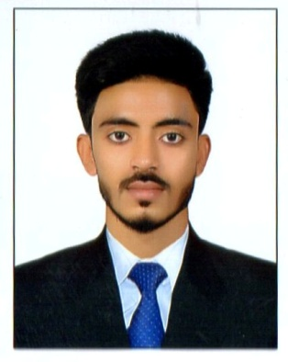
SOHAIL
C/o-CONTACT + 971 503718643
Email: sohail.342176@2freemail.com
Dubai UAE

PROFESSIONAL OBJECTIVE:

To work wholeheartedly for the progress of organization, I offer my skills and experience to achieve organizational excellence for improved profitability. To perform the assigned duties with the best spirit of services and cooperation with colleagues.

PROFESSIONAL BIOGRAPHY:

Organization: Amazon LogisticsServices (India)
Position: Computer Administrator
Period: February 2014 to January 2016 (2y-0m-0d)

JOB RESPONSIBILITIES:

- Worked as receiving return orders (customer cancel).
- Check Quality of each item..
- Investigating inventory shortages and discrepancies.
- Worked as receiving Shipments.
- Manage all items category wise.
- Check Quality of each item.
- Label items according to Shipments.
- Compile reports on various aspects of changes in production.
- Investigating inventory shortages and discrepancies.
- Transfer of new items from receiving to inventory storage.

PROFESSIONAL BIOGRAPHY:

Organization: Global Tree Consultant
Position: Data Entry Operator & Office Assistant
Period: January 2013 to February 2014 (1y-0m-0d)

JOB RESPONSIBILITIES:

- Office Management, Maintenance of Files.
- Preparation & Maintain of Office routine correspondence.
- Memorandum, Purchasing/Distribution of Stationary & Update of Stock file.
- Dispatch Letter & Received Letter Register.
- Preparation & Maintain of office records including leave & attendance.
- Finance records, telephone & electricity bills, and Vehicle log books.
- Support to the senior & Junior Staff in any matter, Fax & Photocopier Machine Operating.
- Hardware & Software (MS. Office Professional, Preparation of Bills & financing work in Excel & Presentation in Power Point, & Internet mailing, browsing, downloading uploading).

QUALIFICATION:

Bachelor of Technology in ECE
(BhaudinZikaria University Multan)
Higher Secondary Education
(Board of Intermediate Education))
Secondary Education (Metric)
(Board of Secondary Education)

COMPUTER & IT SKILLS:

- MS Office & MS Excel and Internet tolls

LANGUAGES KNOWN:

- English
- Urdu
- Hindi

PERSONAL DETAILS:

D.O.B : 15-11-1993
Marital Status : Single
Nationality :Indian
Religion : Islam
Visa Status : Visit Visa

DECLARATION:

I, SOHAIL solemnly declare that the above particulars are true and correct to the best of my knowledge and belief.

