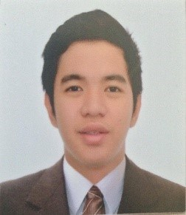
JOMEL
Position Sought: Document Controller/Technical Support/QA/Networking/Data Entry/Any Position
Age: 20 years old
Contact Details: C/o 050236057
E-mail Address: jomel.342237@2freemail.com

Objective:
- Recent graduate seeking a position in a progressive organization wherein I can utilize my educational skills that can help in achieving the goals of the company
- To make the most of my potential and discover new horizons in the field of Information Technology
Skills:
- Proficient in using main Microsoft Office and some programming languages like HTML and Visual Basic.
- Proficient in using the program HTML and use of CSS for web designing through self-study.
- Knowledgeable in networking.
- Ability to meet deadlines while ensuring the accuracy
- Ability to evaluate, prioritize, organize and delegate work schedules and ensure that assigned works are submitted before the deadline
- Can type at least 60-70 words per minute.

Pre- Professional Experience:
Work as an Implementation Intern (Implementation Department) at QnE Software Philippines, Inc. (June 2015- October 2015).
- Creating a TRS (Task Requirement Specification).
- Testing Payroll and Accounting System.

Academic Qualification:
Primary Padre Zamora Elementary School (Pasay City) 2003-2008
Secondary Sta. Clara Parish School (Pasay City) 2008-2012
Tertiary Adamson University (Ermita, Manila) 2012-2016
Bachelor of Science in Information Technology

Seminars Attended:
Career Development for Internship
Explain the skills on how to become a good employee and how professionals choose what to wear and how to act proficiently.
Adamson University, OZ AVR
May 14, 2015

Microsoft Developer Network Session
This seminar mainly explains on how to pull down a system that is made in 2-3 months in just 10-20 minutes by using assembly language. In addition, they had thorough discussion on how to use an asp.net to create a website.
Globe Telepark Valero, Valero St. Makati City.
May 21, 2015

Career Development Seminar for Graduating Students
In this seminar, they explain and share their skills on how to become outstanding employee and how to become professionals including what to wear during interviews, how to act professionally and how to get a job faster.
Adamson University, Adamson Theatre
July 29, 2016

Personal Data:

Language Spoken: English & Filipino (Fluent in written and spoken English)
Date of Birth: May 21, 1996
Nationality: Filipino
Religion: Catholic

