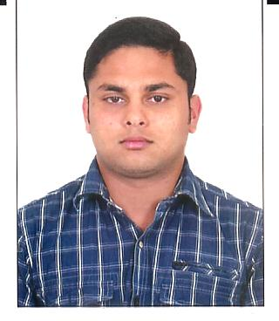
CURRICULUM VITAE
MEBIN
MEBIN.342287@2freemail.com

Objective:
To utilize my abilities and knowledge earned to serve the society and to learn new skills while improving inter-personal skills and to become a successful nurse and to carry out all the responsibilities of a nurse in providing good health care to the patients with proper care and affection
Abilities:
- Good communication skills and aptitude to learn quickly.
- Enjoy working to tight schedules and targets.
- Willingness to take responsibilities.
Educational Qualifications:

COURSE/DIPLOMA | YEAR OF PASSING | NAME OF THE INSTITUTE
DIPLOMA IN  G N M | AUGUST- 2007 | KARNATAKA  AISHWARYA SCHOOL OF NURSING, BANGALORE
PUC | MARCH -2004 | ST. ANTONYS H S S, PLASSANAL, KOTTAYAM
SSLC | MARCH 2002 | ST.MARYS H S S, BHARANANGANAM, KOTTAYAM

Additional Qualifications:

BASIC LIFE SUPPORT (BLS)
ADVANCED CARDIO VASCULAR LIFE SUPPORT (ACLS)
AIRWAY MANAGEMENT
INTERNATIONAL TRAUMA LIFE SUPPORT (ITLS)
PEDIATRIC ADVANCED LIFE SUPPORT (PALS)
Carrier Profile:

HOSPITALS | WORKING PERIODS | AREA OF EXPERIENCE
KAILASH HOSPITALS AND HEART INSTITUTE, NOIDA, UTTAR PRADESH | 13th FEBRUARY 2008  To 5TH SEPTEMBER 2010 | MEDICL $ SURGICAL WARD,EMERGENCY
VIMS SPECIALITY HOSPITALS  MARATHAHALLI,BANGALORE | 15th SEPTEMBER 2010  To 27thFEBRUARY  2012 | EMERGENCY
ZION HOSPITALS PVT LTD  KAMMANAHALLI,BANGALORE | 2nd MARCH 2012  To 13th SEPTEMBER  2013 | EMERGENCY
SPECIALIST HOSPITALS PVT LTD  KALYANNAGAR BANGALORE | 28th SEPTEMBER 2013  To 10th OCTOBER  2016 | EMERGENCY  INCHARGE

Personal Profile:
- Date of Birth : 22nd march 1987
- Sex : Male
- Marital status : MARRIED
- Religion & Caste : Christian, Roman Catholic
- Nationality : Indian
- Language Known : English, Hindi, Kannada, Tamil, Malayalam
Declaration:
I hereby declare that all the information furnished above are true and correct to the best of my knowledge, information and belief.

