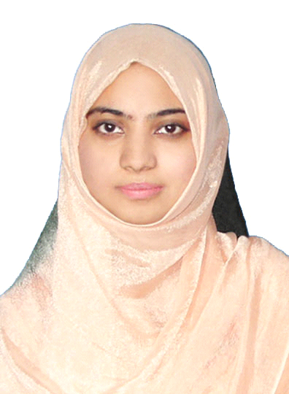
SOBIA
SOBIA.342327@2freemail.com

OBJECTIVE:
To seeking a challenge career in a competitive and environmental where I can utilize my knowledge and experience in the interest of organization to achieve its goal.

WORKING EXPERIENCE:
2012-2015 SIR SYED UNIVERSITY (bscs)
JOB RESPONSIBLITIES:
- LAB CORDINATOR
- TEACHER ASSIT FOR C#,C++,HTML,CSS,english

2011 MARK PRIVATE LIMLITED
CALL CENTER TRANING INSTITUTE (IN MORNING)
1ST MARCH 2011-31 JULY 2011
JOB RESPONSIBLITIES:
- TO teach communication skill
- office administrator
2007_2010 OXFORD HIGH SCHOOL
JOB RESPONSIBLITIES:
- SECONDARY COMPUTER TEACHER

ACADEMIC QUALIFICATION:

2014 Masters in computer science
PAF KEIT KARACHI(EVENING)
Major : SOFTWARE ENGINERING
Subsidiaries: SQL,HTML,C#,CLOUD,ERP

Bachelor of mass communication (2 Years)
UNIVERSITY OF KARACHI
Major : mass communication
Subsidiaries: international relation

2010 3 years (D.A.E) Diploma ASSOCIATE ENGINEERING
SIR SYED UNIVERSITY(AIT)
Computer Information Technology
Board of technical education

2007 Matriculation (Science) from Karachi Board.

EVENT PARTICEPTION/ACTIVITIES
- ENGINEERIN IT FAIR
Year wise 2nd P IT department
Software (HOSPITAL MANGEMENT SYSTEM)
Arrange by on April 2008

- ENGINEERIN IT FAIR
FRY ON PAPAR physics department
Arrange by SIR SYED UNIVERSITY on may 2010

- Seminar
Student participation
Arranged by infinity group in Karachi University 2012
Arranged by2nd year evening student in on Karachi University 29_feb
SKILLS/PERSONALITY

- Ability to work independently as well as part of team
- Have effective knowledge of computer and can sufficiently work o
- Command of MS OFFICE
- Keen user of the internet
- Good interpersonal skills
- Good communication Skills
- Php,c#,c++,c,html
- Software ,documentation

