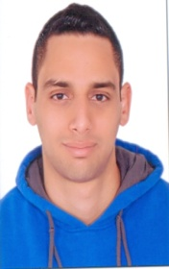
Khaled
E-mail: Khaled.342472@2freemail.com

Personal Data
Gender | Male. |  | Date of Birth | April 6th, 1991.
Nationality | Egyptian. |  | Place of Birth | Cairo.
Marital Status | Single. |  | Military Status | Exempt.

Education
(Feb, 2013) - B. A. in Business Adminstration at Ahram Canadian University
- Major: Accounting.
- GPA: 2.07
Work Experience
- (October2016 – January2017): Worked in “ICE ROLLS” Company as a General Manager at Egypt.
- (September2014 – September2016): Worked in “Egyptian Academy of Certified Public Accountants” as an General Accountant in preparing Financial Statements, Establishing Companies, Taxes, Audit at Egypt.
- (December2013 – August2014): Worked in. “Domina Coral Bay Hotel” in Sharm El Sheikth as a Cashier at Egypt.
- (March2013 – October2013): Worked in “Cortigiano Italian Restaurants” as an Accounts Payable, Inventory, Bank Reconcilation at Egypt.
Computer skills
- Microsoft Office:
- Word Document
- Excel
Personal skills.
- Negotiation Skills.
- Presentation Skills.
- Hard Worker
- Ambitious
- Communication Skills.
- Internet Skills: emails, searching …etc.
Languages
- Arabic Written & Spoken (Native Language).
- English Written & Spoken. (Fluent)
Courses and Certificates
- Certified Trainer at Cortigiano Italian Restaurants as an accountant for Two years
- Attended a Course PFA which stands for Professional Financial Account.
- Attending a Course CPA which stands for Certified Public Account.

