SHAAN
Visa Status: Visit Visa
C/o-(Call) +971502360357
E-Mail: shaan.342597@2freemail.com

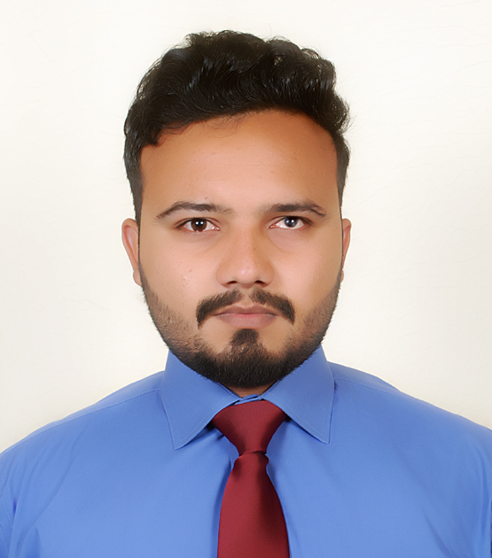

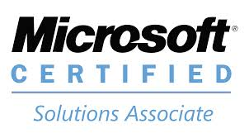

OBJECTIVE:

Seeking A Challenging Job in a professional and dynamic organization where I can serve as well asgroom&utilize my technical and interpersonal abilities.
PROFESSIONAL FIELD EXPERIENCE:

- ASSISTANT NETWORK ADMINISTRATOR (Jan 2015 – Dec 2016)
Brits College and Excellence Center
Job Description:
- Established the whole new computer networks with less errors and Managing, Maintain and troubleshooting of LAN/WAN more satisfaction of our users.
- Increased in number of computer and students with the expansion of computer systems and proper orientation in field of networking.
- Providing industry training to team mates and designing curriculum and strategies to bring and make productive personals for competitive market.
- Established and Configured a Complete Centralized Network System for 45-60 Computers including the Following Servers:
  - DNS server
  - Domain Controller (Active Directory Services)
  - File Server
  - Backup Server
  - Proxy Server
  - DHCP Server
  - Print Server

- Lab Assistant (Feb 2013 – Nov 2014)
I.T Innovation Center
Job Description:
- Maintains computer lab (e.g. instructional materials, appropriate software, sets up materials for daily activities, etc.) for the purpose of ensuring availability of equipment and programs to enhance the instructional program.
- Monitors student activities while in computer lab for the purpose of maintaining a safe environment that is conducive to learning.
- Solving issues related (hardware, trouble shooting, file transfer, driver sharing, internet).
ACTIVE MICROSOFT CERTIFICATIONS:

Microsoft® Certified Solution Expert (MCSE)

Certification Number : |  | F119-1375 | 12/17/2014
Certification/Version : |  | Server Infrastructure 2003

Microsoft® Certified Solutions Associate (MCSA)

Certification Number : |  | F115-5589 | 12/17/2014
Certification/Version : |  | Windows Server 2003 and 2007

Microsoft® Certified PROFESSIONAL (MCP)

Certification Number : |  | E873-3244 | 07/09/2014
Certification/Version : |  | Microsoft Certified Professional

Other Information Technology Certifications:

 | Course’s | Institute / University / College. |  | Date Completed
 | Computer Fundamental’s. | MICROSOFT Study Center. |  | 2013
 | Computer Mechanics | MICROSOFT Study Center. |  |  | 2013
 | MCSE 2003 Training | MICROSOFT Study Center. |  |  | 2014
 | MCSE 2007 Training | MICROSOFT Study Center. |  |  | 2014

Education Qualification’s:

 | Degree | Institute |  | Date Completed
 | Metric | BISE Gujranwala, Pakistan. |  | 2009
 | LAN/Networking | Airport Road, Sialkot Pakistan. |  | 2011

Technical &Professional Skills
System Technician | Documentations.
Windows | Internet
Installations | Social Networking
Partitions | Networking.
Drivers Installations | Workgroup
User | User management
Troubleshooting | User and Data Centralize
Networking | Security
Level Sharing | Server / Client Level Shearing
Computer Level | Servers.
Sharing | DNS Server
Security | Domain Controller Server
Quota | File Server
Encryptions | Backup Server
User management | Print Server
Disk Management | DHCP Server
Compression | Proxy Server

