CURRICULAM VITAE
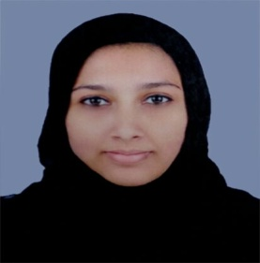

SHAHANA
C/o-MOB: +971502360357
ABUDHABI
e-mail: shahana.342643@2freemail.com

_____________________________________________________________________________________

OBJECTIVE

My objective is to secure a worthy position in your group which will give the opportunity to contribute the very best of my skills that can add to the overall development of the group, and at the same time improve my professional skills and ability, while being resourceful, dedicated, obedient, innovative and flexible.

EDUCATIONAL QUALIFICATION

- Passed Degree B.Sc. Computer Science -2014
- Passed plus two examination – 2011
- Passed secondary school examination - 2009

TECHNICAL QUALIFICATION

- Diploma in Office Automation & DTP
- Computer fundamentals & Familarising devices ,MS-Windows XP,MS-Word ,MS-Powerpoint, Internet, Email, Adobe pagemaker, Adobe photoshop

WORK EXPERIENCE

- Worked as Receptionist for Five Months at EMIRATES SMART KITCHEN & HOME INTEROIRS , Thrikkanapuram , Malappuram .

PERSONAL PROFILE

Date of Birth - 30/09/1993
Sex - Female
Marital Status - Married
Visa Status - Visit visa
Languages Known - English, Malayalam, Hindi
Nationality - Indian
TECHNICAL SKILLS

Language : c, c++, java programming, .NET Technology
Operating system : Windows XP/2007/2008
.Net Technology : VB.NET, ASP.NET, ADO.NET
Web service : IIS
Web Technology : HTML, Javascript

AREA OF INTEREST

- Computer Networking
- Software Engineering

ACADEMIC PROJECTS

- Major Project :` Remote File Access – Android, java & .net
application
- Mini Project : Project Tracking Tool –Android &.net application

EXTRA- CURRICULAR ACTIVITIES

- Participated in State Level GURUSHISHYA EXAM
- Participated in English Elocution of ILM(Institute Of Language Management) Bangalore
- Member of NSS(National Service Scheme)

DECLARATION

I hereby declare that, all the facts given above are true & correct to the best of my knowledge & belief. I am also confident of my ability to work in a team & execute my responsibilities.

