MILIND 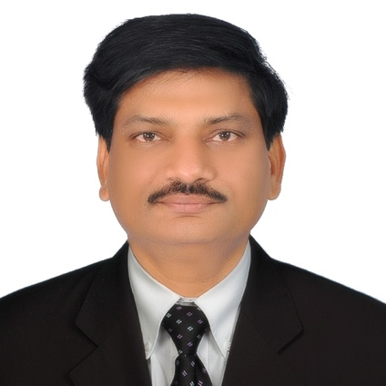

45 years
Married
English/Hindi/Marathi
Diploma In Elect. Engg

E-mail: milind.342688@2freemail.com
_________________________________________________________________________________
Professional Summary

22 years+ Industrial experience in the Welding and Fabrication industry. An innovative result-oriented Engineer, determined to achieve the next milestone through process optimisation, automation and setting up procedures. Never-give-up attitude when confronted with challenges, ensuring ownership of work of every team member who is engaged to contribute and share in the success.
Key Start up member and able to achieve targets with excellence.
During the career gained practical, hands-on experience in Machine Automation, PLC Programming, Machine designing & manufacturing, Plant Engineering, Hydraulics, Pneumatics, Motors, Drives, Servo systems, Electrical & Mechanical systems, Project management, In-House project developments, Cost effective power management, Safe working procedures, 5 S culture, Inventory control, ERP systems and Plant capacity expansions
Successfully installed 3 state-of-the-art Monorail type Automatic Blast and Paint line in the industry.

Professional Experience
Mabani Steel LLC, Ras Al Khaimah, UAE Nov. 2006 – Till Date
Current Position:- Plant Engineering and Maintenance Manager.
Achievements and Contributions:-
- Reconditioned several used machines and reinstalled thus saving valuable resources
- Automated Purlin Roll Former from manual to Servo driven automatic punching and slitting.
- Automated Wall sheeting machine with automatic batching and length control.
- Automated and refurbish 30 year old Blasting machine from scrap and make it functional and still running in plant
- Reduced critical machine downtime by 75% by implementing extra ordinary efforts in understanding root causes of failure and finding correct solutions to such problems resulting in 30 % productivity.
- Reduced maintenance man hours per metric tons by 125% from 3 to 1.2
- Developed, conceptualised and programmed state of the art Automatic Blast and Paint line with Italian monorail manufacturer, Indian programmer and Project manager.
- Manufactured and engineered several punching and cutting dies for higher productivity of standard parts.
- Designed and manufactured semiautomatic Flange punching line.
- Developed and manufactured two Heavy duty tacking fixture for tacking heavy beams which are not possible on Auto weld lines.
- Manufactured small Plate rolling machine, Flange punching line, Different capacity roller conveyors.
Other contributions:-
- Used various techniques and guidelines to ensure a safe working environment around plant and premises. Ensured all maintenance workers are following prescribed safety policies and guidelines.
- Recommended different methods of improvement and expansion in current facility to improve safe and efficient working which resulted in increased productivity
Key Functions:-
- Worked as part of management team to share ideas and improve operation, recommending, supporting and implementing continuous improvement activities. Process and procedure improvements to optimise results and improve quality of delivery.
- Provided strong leadership and technical expertise to maintain existing procedures and continuous improvement.
- Recommended measures to improve conditions and operations of machines and equipment. Performed Root cause analysis and resolved problems.
- Maintained records and tracked work orders, spare parts and maintenance history of equipment through computerized system.
- Managed the process of introduction of new machinery, plant and equipments from plant engineering, selection of machines, installation, training and handover.
- Develop a planned Preventive Maintenance schedule to ensure full preventive maintenance is carried out.
- Performed Root Cause Analysis and resolved problems.
Department Management:-
- Mentored and guided maintenance and repair work performance.
- Supervised maintenance management staff and conducted performance reviews of workers and technicians
- Develop, implement and manage Key Performance Indicators (KPI) for each area of responsibility
- Worked within approved budget. Developed and implemented cost saving measures, contributing to profits and revenue by conserving organizational resources.
- Lean Maintenance workforce.
- Plans, develops and implements new methods and procedures designed to improve operations, minimize operating cost and effects greater utilisation of Man, Machine and Material.
__________________________________________________________________________________
Mogora Cosmic Pvt. Ltd. Pune. June 1995 – Oct. 2006
One of the best welding and special purpose welding machine manufacturer in India.
Last Position Held: - Manager- International Product Division.
Responsibilities:- All India Marketing, sales and service of products from
OTC Daihen Corporation, Japan
REHM, Germany
PHI- (Conrac Autoweld Manufacturer), USA.

I joined as an Electrical Engineer for manufacturing and standardization of various control panels for Welding Rotators, Positioners, Column and Boom and special purpose machines. After standardization, I was transferred to After Sales Service department followed by the Product Development department.
When Mogora secured all India dealership of OTC Daihen Corporation, Japan, I trained in Japan on advanced welding equipment like Thyristor controlled, Inverter controlled welding power sources. Later, when Mogora tied up with German welding machine manufacturer REHM Gmbh, I was trained in Germany.
When Mogora secured the dealership for PHI (Conrac Autoweld Manufacturer), USA who manufacturer Structural beam welding machine, Presses and Pipe bending machines. I was deputed to PHI- USA for training. I completed the training with Grace. Installed full Autoweld welding line in India (Tata BlueScope, Pune).
___________________________________________________________________________
Armatech Associates, Pune 10 Months
Position:- Electrical Engineer
Responsibilities:-
Manufacturing thyristor controlled electronic controller for magnetic chucks, magnets and moulding machines; provided after sales service to customers.
Installed controller in Kirloskar Ferrous, Hospet, Karnataka for Engine moulding machine.

