CURRICULUM VITAE

ABDUL
ABDUL.342727@2freemail.com
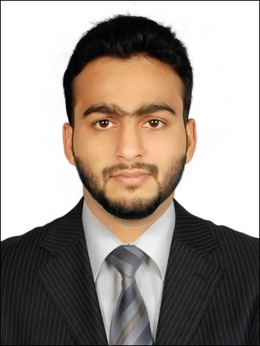

Career Objective:

Seeking an objective for professional growth and increasing responsibility as professional in an organization where team spirit and skills are recognized and rewarded.Capable and confident to work in the field of accounting and Information technology stream.

Educational Qualifications:

- Bachelor Of Computer Application
Srinivas Institute Of Management Studies( Mangalore University 2010-2013)

- 12thGrade 2008-2010
IEMHSS, Kasaragod

- SSLC 2006-2008
IEMHSS, Kasaragod.

Certifications:

- Diploma In Indian And Foreign Accounting
G-Tec Computer education with A+ grade.(2016)

- Microsoft Office Specialist
G-Tec Computer education(2016)

- Certification on Programming Language PHP
Source page Learning pvt ltd,(2016)

Computer Skills:
- Indian and Foreign Accounting (Tally, Peachtree, Quick Books).
- MS. Office (MS Excel)
- Familiar with Internet and Mailing
- Software Languages: Basics of C, C++, java, PHP,HTML

Synopsis:
- Adopt any circumstance, flexible to learn new things,Good Interpersonal skills.
- Self-motivated, energetic & optimistic person who worksas a heart of a team
- Excellent in Writing & Oral Communication, InterPersonal, and problem solving skills with the ability to work in multi-cultural environment

Academic Project:
Project: Net banking
Language of Implementation: PHP
Operating System: Windows 2000/XP/7/8

Description:
In this project a website is designed for banking through online. Net-banking facilitates the bank customers to perform their financial transactions in a secure web environment operated by their building society or a bank“NET-BANKING” the execution of financial services via internet, reducing cost and increase in convenience for the customer to access the transaction.Net banking is an umbrella term for the process by which a customer may perform banking transaction electronically without visiting a brick-and-mortar institution .

Declaration:
I hereby declare that the above-mentioned information is correct up to my knowledge and I bear the responsibility for the correctness of the above-mentioned particulars.

