APARNA  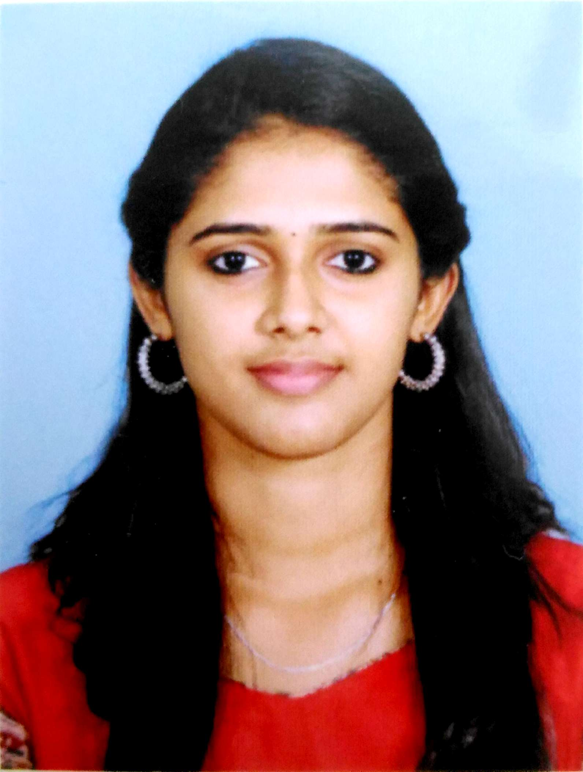  PERSONAL DATA:  Age & Date of Birth : 22, 11/12/1994  Gender : Female  Nationality : Indian  Marital Status : Single  Mother Tongue : Malayalam  Languages : English, Malayalam, Hindi | Objective :  To work in a reputed organization with a creative and challenging environment using all my knowledge, where I could constantly learn and successfully deliver solutions to problems as a dedicated employee.  Personal:  Organized, dependable and innovative. Detail oriented. Maintains discipline, good work habits, ethical conduct, and a philosophy of life-long learning. Meticulous about the quality of products, documents and the work environment. Works well with others to accomplish goals and foster individual development.  Accomplishments :  - Fluent in English.  - Able to work under challenging situations.  - Good analytical and managing skills.  - Ability to learn things quickly.  Leisure pursuits :  - Listening to Music.  - Reading books ,Surfing the net  - Interested in sports  Softwares Known :  - AutoCAD (Certified Professional)  - Revit Architecture (Certified Professional)  - 3Ds max  - Primavera  - Staad Pro  - MS Office
EDUCATIONAL QUALIFICATION:

Course | Institution | Board/University | Grade | Year
10th | Sree Vivekananda Memorial Public School  Aralumoodu, Trivandrum | CBSE | Distinction | 2010
12th | Saraswathi Vidyalaya,  Vattiyoorkavu, Trivandrum | CBSE | First Class | 2012
B.Tech  (Civil Engineering) | PRS College Of Engineering, Paliyode  Trivandrum | Kerala University | First Class  CGPA-7.63 | 2016

Career Highlights
Planners,
Trivandrum

Designation: Junior Engineer
3rd August 2016 – January 31st 2017

Junior Engineer

Under the general guidance and supervision of the Managing Director and in accordance with the set policies and procedures of the Company, completed a series of submission drawings and files. Work for such projects involves

- Construction Planning & Project Management
- AutoCAD, Revit Architecture & 3Ds max drawings and works
- Preparation and estimation of quantities
- Procurement of materials

Training & Workshops :
- Experience from final year project, ‘Designing and Planning of Residential Buildings’
- Industrial visit at Sobha Ltd, Bangalore.
- Workshop on “Design of Bridge” under IBCC India
Key Responsibilities :
- Good reasoning and communication Skills
- Positive attitude towards work and great ability towards result oriented output.
- Good organizational and time management skills.
- Highly organized and used to working to tight deadlines
- Exceptional accuracy and attention to detail, strong MS Office.
- Ability to work in a team environment and on own initiative
- Detailed understanding of risk and internal controls.

Declaration :

I hereby declare that the above information given about me is correct and true to the best of my knowledge.

