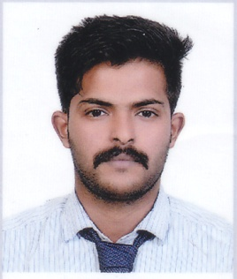
SHAFEEL
Email : shafeel.342816@2freemail.com

CAREER OBJECTIVE:
Seeking a challenging opportunity with your organization where my knowledge, skill and potentials can be extensively applied and allows me to learn new environments and concepts for my career growth.
PERSONAL DETAILS:

Date of Birth : 29/09/1994
Sex : Male
Religion & Caste : Muslim
Nationality : Indian
Marital Status : Single
Languages Known : English, Malayalam & Hindi
Driving Licence Details : Valid Indian Driving Licence for LMV and Motorcycle with Gear
PASSPORT DETAILS

Passport Expiry : 05/12/2026

EDUCATIONAL QUALIFICATION:
- SSLC
- HSE (Commerce)
- Bcom

PROFESSIONAL QUALIFICATIONS:
- IATA –UFTAA Foundation in Travel and Tourism (ITDI Montreal, Canada)

TECHNICAL QUALIFICATION:

- Amadeus& Galileo
- Accounting

HOBBIES:
- Driving
- Football
- Traveling

DECLARATION:
I hereby declare that the particulars furnished above are true to the best of my knowledge and belief.

Place :
Date :
SHAFEEL

