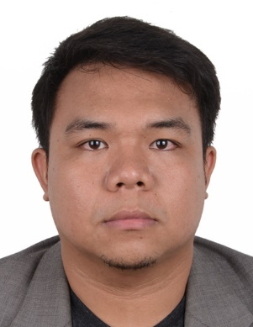

Jay
JAY.342828@2freemail.com

Objective
To apply for medical nurse position to further my experience as a health care worker in a busy and professional environment.

Qualifications
- Registered nurse with 3 years and 6 months experience in government hospital.
- HAAD Licensure passer
- Basic life support trained
- First Aider
- Skilled in EMERGENCY ROOM, MALE/FEMALE MEDICAL WARD, MALE/FEMALE ISOLATION WARD, PEDIATRIC WARD, OUTPATIENT DEPARTMENT.

Work Experiences

Staff Nurse
Valladolid District Hospital
Valladolid, Negros Occidental, Philippines
July 2013- Present

Nurse Volunteer
Valladolid District Hospital
Valladolid, Negros Occidental, Philippines
October 2010- April 2011

- Provided patient care for 10 patients in the area assigned.
- Performed clinical duties according to hospital policies
- Facilitated the admittance and discharge of patients.
- Assisted in the orientation of new staff members.
- Assessed patient conditions and advised of changes in status.
- Monitored and maintained patient charts.
- Aided patients and family members in the education of health care needs.
- Assisted patients in emergency situation in Emergency/Trauma room.

Nurse Volunteer
Canadian Organization/Urban Angels Medical Mission
Philippines
February 19, 2012-March 2, 2012
February 15-20, 2015
- Collecting patients over all data
- Assisted in cataract operations.
- Keeping a log of medical supplies received
- Packing medical supplies for trips
- Assisting the team in overall operations
- Worked with foreign volunteers.

In-house Private Nurse

Valladolid, Negros Occidental, Philippines
2012-2013
- Provided personal nursing care.
- Measured and recorded patient's vital signs such as weight, temperature, blood pressure, pulse and respiration.
- Assisting patient during eating, mobilization and daily routine care
- Secured proper observance of doctor’s advices on patient’s condition.
Review Assistant

Professional Review Network Inc.
Bacolod City, Negros Occidental, Philippines
December 2009-July 2010
November 2011- Sept 2012
- Assisted the Lecturers in reviewing examinees for Philippine Nursing Licensure Exam
- Acted as sub-lecturer on various health topics
- Coordinated with a team in organizing the daily lectures.

Skills/Characteristics

- Have a strong drive and determination
- Hardworking attitude and has a good moral character
- Demonstrate attitude in developing new skills and easily cope up with changes
- Has a positive attitude and ability to multi-task effectively
- Ability to understand the problems of members in team
- Flexible and can easily adapt to several situations
Related Activities/Seminars

- “Ebola Virus….A Global Health Threat’’ January 31, 2015
- “Understanding Depression” September 14, 2013
- “How to Cope with Depression” September 14, 2013
- “Incidence of Depression” September 14, 2013
- Participated in Environmental and Community Outreach Programs as a member of Balayan (Campus Club) 2007-2009
- Gender Sensitivity Seminar 2006

Education

Tertiary
University of St. La Salle, Bacolod City, Philippines
2005-2009
Course: Bachelor of Science in Nursing

Secondary
Ramon Torres National High School, Bago City, Philippines
2001-2005

Primary
Valladolid Elementary School, Valladolid, Philippines
1995-2001

