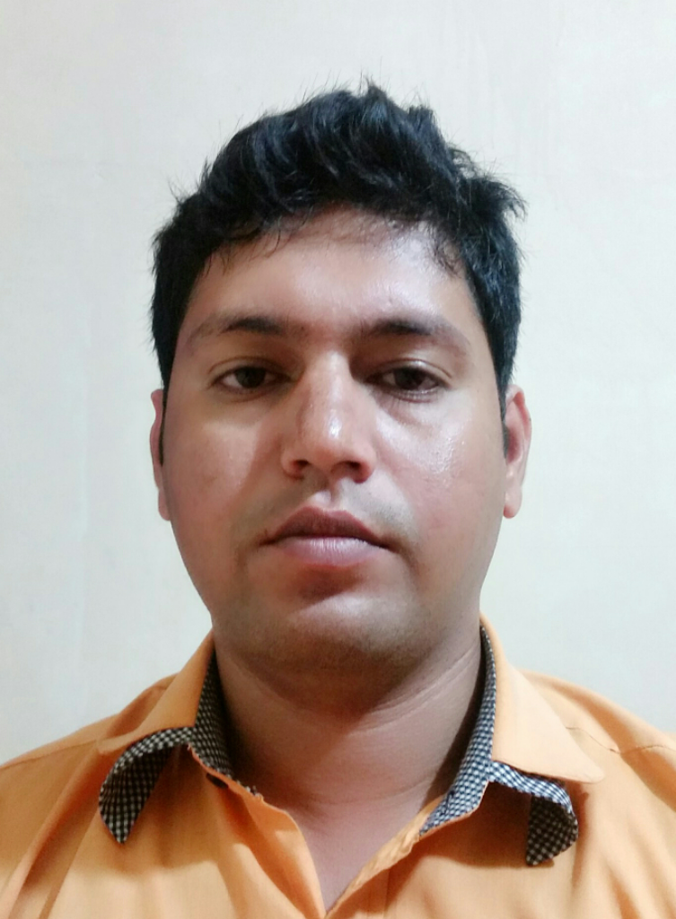
JAVID

Personal Information

Date of Birth : 03/03/1992
Place of Birth : D.G.K khan (Pakistan)
Nationality : Pakistani
Religion : Islam
Email : JAVID.342900@2freemail.com

Pasport detail

Issue Place. : Pakistan
Issue Date. : 18-01-2013
Expiry Date. : 16-01-2023
Objective

I Want to work under your kind control where my skills and competencies would allow me grow with the growth of organization.
Academic Qualification

Exams / Degree | Div. | Board / University | Year
Matric (Science) | 2nd | BISE, D.G. Khan | 2008
DAE (Computer Information Technology) | 1st | P.B.T.E Lahore | 2011

Computer Skills:

- HTML ,C++ ,DATABASE, VISUAL BASIC, ADOBE PHOTO SHOP
- MS OFFICE, INTERNET, NETWORKING, INPAGE, WEB DESINGING
- SOFTWARE & HARDWARE (Complete)
Experience:
- 6 Month Experience in Medical Pharma
Duties
- Prepare invoice regarding to medicine
- Issued and maintain records of payments bills
- Entered and maintain all records of sold and purchased products (medicines)
- Coordinate with pharmaceutical companies through emails
- 6 Month Experience in Photo Shop
Duties
- Work on adobe photo shop
- Work on MS Office
- 2 Year Experience in Al-Imran Education College & Acadmy
Duties
- Paper composing
- Prepare schedule for monthly test
- Prepare monthly result
- 1 Year Experience in PEPSI
Worked as a merchandiser

