CURRICULUM VITAE
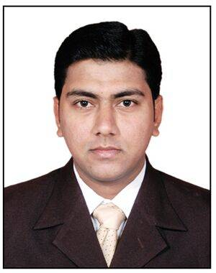
SADIQ
C/o-Mobile : +971505891826
Email : sadiq.342950@2freemail.com
Dubai, UAE.

PROFESSIONAL OVERVIEW:
With a sound academic background, I have been provided a solid foundation of disciplines, values and work ethics. This combined with my enthusiasm and a desire to succeed allows me to perform and respond efficiently and effectively to the demands of various business environments.
CAREER OBJECTIVE:
I am seeking a position that will provide me the opportunity to obtain a career growth oriented position by setting standards of excellence and to help the company achieve its objectives and boost its corporate image.
EDUCATION:

Course | Board | Year
M.B.A. | JNTU – Hyderabad, India | 2016
B.Com. | Osmania University – Hyderabad, India | 2012
EXPERIENCE:

Marsh Consultancy Services Pvt. Ltd. (India) (from June 2012 - December 2016).

Sr. Backend Executive
- Prepare the customers verification reports of Credit Cards, Auto and Home Loans etc.
- Tele Verification of Credit Cards and Loan Customers.
- Allocation of daily adhoc requests to team members and make sure the timeline are followed with accuracy.
- Preparing daily productivity reports of all the team members.
- Preparing monthly billings of team members.
- Follow-up on the status of loans with Executives.
- Submit information to concern banks on regular basis.
- Provide feedback through emails in case if any.

Terabeam Proxim Wireless Pvt. Ltd. (India) (January 2010 - May 2012).

Data Processing Executive
- Used to take care of complete Data Processing.
- Collect Email ID’s of clients which are attached with organization.
- Enable new partners in Sales force.
- Maintained the complete price book of the items.
- Make changes in products and prices upon request like end of life (EOL), slow moving products.
- Use to upload new products on Social Media.

Technical Skills:

- Computer Skills : MS-Office (Word, Excel, Power Point, Outlook).
- Typewriting : Lower Grade
- Typing Speed : 60 wpm
PERSONAL DETAILS:

- Date of Birth : 15-08-1987
- Gender : Male
- Religion : Islam
- Marital Status : Single
- Language : English, Urdu & Hindi
- Hobbies : Playing Cricket & Indoor Games

