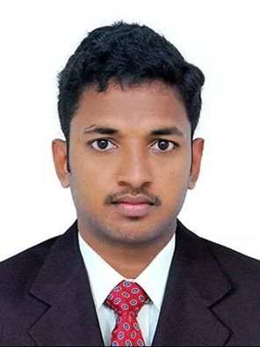
CURRICULUM VITAE

SANEESH
C/o-Mob : +971503718643
E-mail: saneesh.342959@2freemail.com

CAREER OBJECTIVE
To pursue a career with companies having a global vision that encourages creativity & offers an opportunity to learn & develop both in professional & personal life, wish to use & enhance my technical knowledge & ability to work in groups.
PERSONAL SKILLS

- Positive thinking and perfect planning with hard work.
- Communication skills.
- Quick learner and dedicated with an ability to grasp new ideas and concepts
- Work well individually as well in team, hard working.

EDUCATIONAL QUALIFICATIONS

Name Of Examination | Board / University
B.Com (Co-operation) | Completed With one arrear (Calicut University)
PLUS TWO | Board of Higher Secondary Examination Kerala
SSLC | Board of Public Examination Kerala

TECHNICAL SKILLS

- Tally
- Dubai Custom Online Documentation (Mirsal II )
- Graphic Designer (PageMaker , Corel Draw , Photo Shop)
- Typing (English)
- MS Office
- Internet

DUTIES AND RESPONSIBILITIES

- Online Documentation (Mersal II ) (Import & Export ) (Sea and Air )
- Petty Cash (Manual Leger and Tally)
- Bank (Manual Leger and Tally)
- Maintaining Consignee Ledger (Manual Leger and Tally)
- Weekly providing Outstanding Ledgers to Consignees
- Credit Card Payment Ledger (Manual Leger and Excel )
- Preparation of Invoices
- Maintaining Of Stock (Ready Made Garments ) (Manual Leger and Tally )
- WPS salary
- Utility Payments
- Preparing Trail Balance, Balance Sheet, Profit And Loss Account
- Updating status to customers of Shipment arrival
- Planning off Delivery Order Collection
- Making Of Cheque For Delivery Order Collection
- Maintaining Each Shipments Expenses Separately (Manual leger and Excel)
- Planning of Delivery Pickup and Smooth delivery
- Maintaining Validity Dates Of Shipments (DO,DPA) (Manual Leger and Excel )
- Maintaining Transportation Details (Manual Leger and Excel )
- Maintaining Drivers Separate Trip Ledger (Manual Leger and Excel )
- Monitoring Drivers
- FIRS Pepper Making
- Dubai Custom Code Registration
- Dubai Custom code renewal
- Arranging Inspection and Smooth Releasing Of Shipment

PERSONAL INFORMATION

Date of Birth : 11/11/1991
Sex : Male
Marital Status : Single
Religion : Hindu
Nationality : Indian

LANGUAGES KNOWN
- Speak English, Hindi, Malayalam, Tamil
- Read English, Malayalam, Hindi
- Write Malayalam,English,Hindi

PASSPORT DETAILS

Date of Issue : 11/12/2012
Date of Expiry : 10/12/2022

LICENCE DETAILS (INDIAN)

License type : M/C With GR And Light Motor Vehicle
Date of Issue : 03/01/2012
Date of Expiry : 02/01/2032

EXPERIENCE
- Working as ACCOUNTANT cumDUBAI CUSTOM DOCUMENTATION CLERK (MIRSAL II )in SMOOTH WAY CARGO LLC since 28/09/2014 at DUBAI,UAE
- Working as ACCOUNTANT in KINGS CLUB TRADING LLC since 28/09/2014 at DUBAI,UAE
- Workedas ACCOUNTANT in PRIVATE COMPANYat Tirur(INDIA ) above 1.5 year
- I have worked as a Computer Hardwareabove 1 Year

DECLARATION

I hereby declare that all the details furnished above are true to the best of my knowledge and belief.
Saneesh

