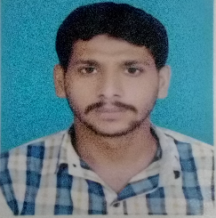
Site Engineer
CURRICULUM VITAE

Name: Asim
C/o-Contact: +971501685421
Email Address: asim.342978@2freemail.com
OBJECTIVE

To achieve excellent results in life through extra ordinary hard work ,honest, dedication to duty and enhance goals of my organization of my life.
Want to work in a challenging environment where I can get the change of growth.
EDUCATION

Academic Achievement
Name of exam. Department. Marks. Year. Board.
Matric Science 764/1050 2009 BISE / Gujranwala
TECHNICAL EDUCATION AND AKILLS

Qualification. Mark. Year. Board
D.A.E. Civil (diploma three year) 2153/3350 2012 PBTE/Lahore

Computer Literate.
Auto cad. Microsoft words excel .Computer hardware. Software

Language. Spoken : English, Urdu, Panjabi

Personal Information
Religion : Islam
Nationality : Pakistan
Marital status : Unmarried
Date of birth : 02/ May/ 1992
Personal Details
This is to certify that Asim. has worked with us a Site Engineer on project Sialkot international airport for the period from oct 05, 2012 to .Aug 2013.Canal city Sialkot ONE YEAR month.
During his stay, worked diligently remained regular and punctual .His behavior with concerned department was excellent and we wish him good luck and bright future.
UAE WORK one Year

Profile:
- Overall one Years of experience as Site Engineer of various infrastructure projects such as, irrigation, sewerage, utility/pipelines, land developments.

Declaration
I hereby declare that all information given above is true and correct to that best of my knowledge.

