PROFESSIONAL EXPERIENCE
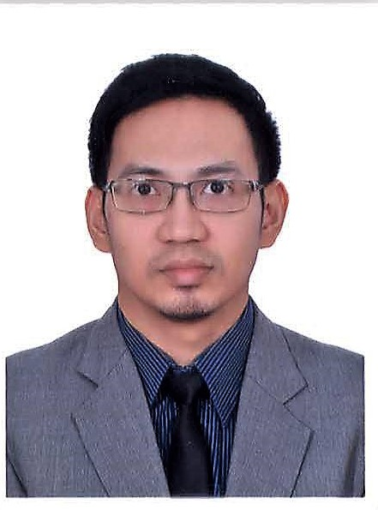

Mark

13 years of profound Middle East experience in Education and Banking & Finance centered in Administration

Objective
To continue a legacy that would help me share my abilities and positively influence my growth and to support the company with utmost diligence and perseverance.

Skills & Abilities
- Proficient in Administrative and Secretarial duties
- Multitasking
- Organizing event skills
- Excellent Communication and Correspondence
- Effective, Productive and Contributive Team Member
- Proficient in Microsoft Office
E: mark.343015@2freemail.com
B: February 18, 1980 (37 y/o)

gULF MEDICAL UNIVERSITY, AJMAN, UAE
EXECUTIVE ADMISSIONS OFFICER cum SECRETARY

december 2009 – october 2016
Main Responsibility: Assist the Registrar in the admission and evaluation of prospective students enrolling for the various programs in the university. Acts as a Personal Secretary to the Dean.

IMEC – Dubai islamic bank & Standard chartered bank, sharjah, uae
RETAIL CREDIT STAFF cum DATA ENTRY OPERATOR

september 2003 – october 2009
Main Responsibility: Performed a very extensive job of quality check in all data entry information of credit cards in the banking system. Ensure quality checking in the support unit and maintain the records at all times.

Education

POLYTECHNIC UNIVERSITY OF THE PHILIPPINES

BACHELOR IN HOTEL AND RESTAURANT MANAGEMENT
AY 1997 - 2001

COMMUNICATION
Very fluent in English language (Oral, Written and Reading)

JOB RESPONSIBILITIES:

GULF MEDICAL UNIVERSITY

(AS AN ADMISSION OFFICER)

- Administer all the type of inquiries (i.e. phone, on-line, personal, etc.) and in-put all the information in the Student Management System.
- Answer all on-line inquiries thru Outlook / Send feedback to applicants with regards to the outcome of their application
- Ensure the files are sorted according to the status of the application (Inquires, For Interview, Interviewed, Admitted etc.)
- Print, compile and initiate the pre-assessment of the admission documents for evaluation
- Facilitate the assessment test and interview procedures
- Prepare and send various type of admission letters
- Guide applicants for the final stages of admission including fee payment, completion of documents, visa processing and hostel reservations.
- Prepare monthly and annual reports
- Serves as a counsel in school exhibitions such as GETEX
- Complies with the quarterly reports for CHEDS
- Act as a next-in-charge in the absence of the Assistant Registrar
- Other duties that may be assigned by the Dean and HOD

(AS A SECRETARY OF THE DEAN)
- Check the emails, personal notes, messages of the Dean and make sure that each and everything is accounted for; replied and made sure that actions are carried out
- Responds to daily correspondences in both professional and personal concerns
- Receives and make phone calls and relay messages to the Dean
- Ensuring meetings are effectively organized and minuted
- Maintaining effective records and administration
- Receiving and circulating agendas, memos and reports
- Keeping up-to-date contact details for the management committee and ordinary members of the organization
- Keeping a diary of past and future activities
- Preparing reports of the Admission activities for the annual general meeting
- Exposed to basic Accounting duties within the Admissions Office as far as tuition and miscellaneous fees are concerned

JOB RESPONSIBILITIES

IMEC – DUBAI ISLAMIC BANK AND STANDARD CHARTERED BANK

- Receive / acknowledge all applications from branches, direct sales and tele sales & maintain detailed MIS at all times.
- Pre-screening – provide comments after verifying the documents, statements & highlight ambiguity if any.
- Checking all the files against internal negative list & escalate to management for a match found & update the negative list accordingly.
- Calculating average balance / credit turnover for self-employed applications.
- Daily tracking & Powercard update of all approved, pending & rejected applications & aftersales request.
- Maintain the MIS for daily approval, rejection & conditional approval cases & provide the MIS whenever requested by the management.
- Coordinating with the Direct sales & Tele sales Department & update them daily with MIS.
- Update daily & monthly manager's MIS to extract data for monthly presentation to the management.
- Assists in creating a departmental portfolio as an entry to one of the most prestigious organizational merit and Performance Excellence award.
- Perform some editorial post for Manager's correspondents
- Intervene with financial analysts in evaluating some overlooked pointers and/or policy outline.

trainings and seminars:

standard chartered bank (scope international, chennai, india)

NOvember – december 2005

M2 CATERING SERVICES, PHILIPPINES – 2001
DUSIT HOTEL NIKKO, PHILPPINES – 2000
CHINOIS FRENCH RESTAURANT, PHILIPPINES - 1999

other useful information

ACCOMPLISHMENTS:
- Established growth from a simple rank-in-file position into a more reputable member of the Admissions team governing a rather more significant role alongside with the University Registrar. (Candidate to be the next Assistant Registrar.)
- Developed a very well-versed and professional approach in a diverse and multicultural setting
- Being part of the finance analytical core of the Retail Card Department with a significant role in a pre-screening committee.
- Chosen as one of the editorial team alongside with the Sr Credit analyst and Team Leader.
- Recognized as member of the Best Support Team Category in the Performance Excellence Award.
- Maintained more than 3 years of credible & outstanding role as a quality assurance personnel in SCB (COD division)
- Chosen to conduct a training & turnover program for Scope International (SCB – Chennai, India); Featuring the EBBS / Escapes banking system

VISA STATUS:
- Visit Visa

