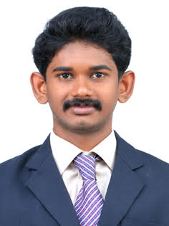
SREERAG

E mail id: sreerag.343028@2freemail.com

Career Objective:

Work to the expectations of the employer which paves the way for achievement of organization goals and simultaneously making career progression.

Skills
Good communication skills.
Confidence.
Self Control.
Patience.
Decision making skills.

Education:
S. No | SSLC / PLUS-2/ Degree/Diploma/PG | Year of Passing | University/Board | %age / CGPA
1 | SSLC | 2008 | STATE BOARD | 69%
2 | PLUS-2 | 2010 | HSE | 56%
3 | BBA | 2013 | Calicut University | 71%
4 | MBA | 2013-2015 | Bangalore University | 62%

Experience:
Company: | HDFC BANK
Location: | THRISSUR,KERALA
Description: | April 2016 Jan-2017  Branch officer (sourcing accounts, and kyc operation)

UG Project:
Company: | RACE ,MOTRS
Location: | EANGADIYOOR ,THRISSUR,KERALA
Description: | The main of the project was to do sales promotion.

PG Internship:
Company: | MILMA , DIARY THRISSUR
Location: | THRISSUR
Description: | The main idea of the internship was to do an organizational study.  Learned about the overall functionalities of the company.

Awards & Achievements:
Academic | - Participated in environmental seminar in Mother college,Thrissur  - Participated in various workshops conducted by Mother college
Extra-Curricular | - Active member of National Cadet Corps  - Active Member of NNS in mother college  Participated in district Level Badminton Tournament conducted by Mother college.  Active member of Anti Tobacco Squad

Seminars/Conference/Workshop Participated:
- Entrepreneurship workshops conducted by ABBS.
- Workshops on Leadership conducted by ABBS.

Personal Profile
D.O.B | 02-02-1993
Mother Tongue | Malayalam
Language known: | - English  - Malayalam  - Tamil
Native Place | Guruvayoor, Kerala
Aadhaar Card
Driving License
Passport port No

Place: Thrissur
Date: 09-02-2017 Signature:

