RESUME
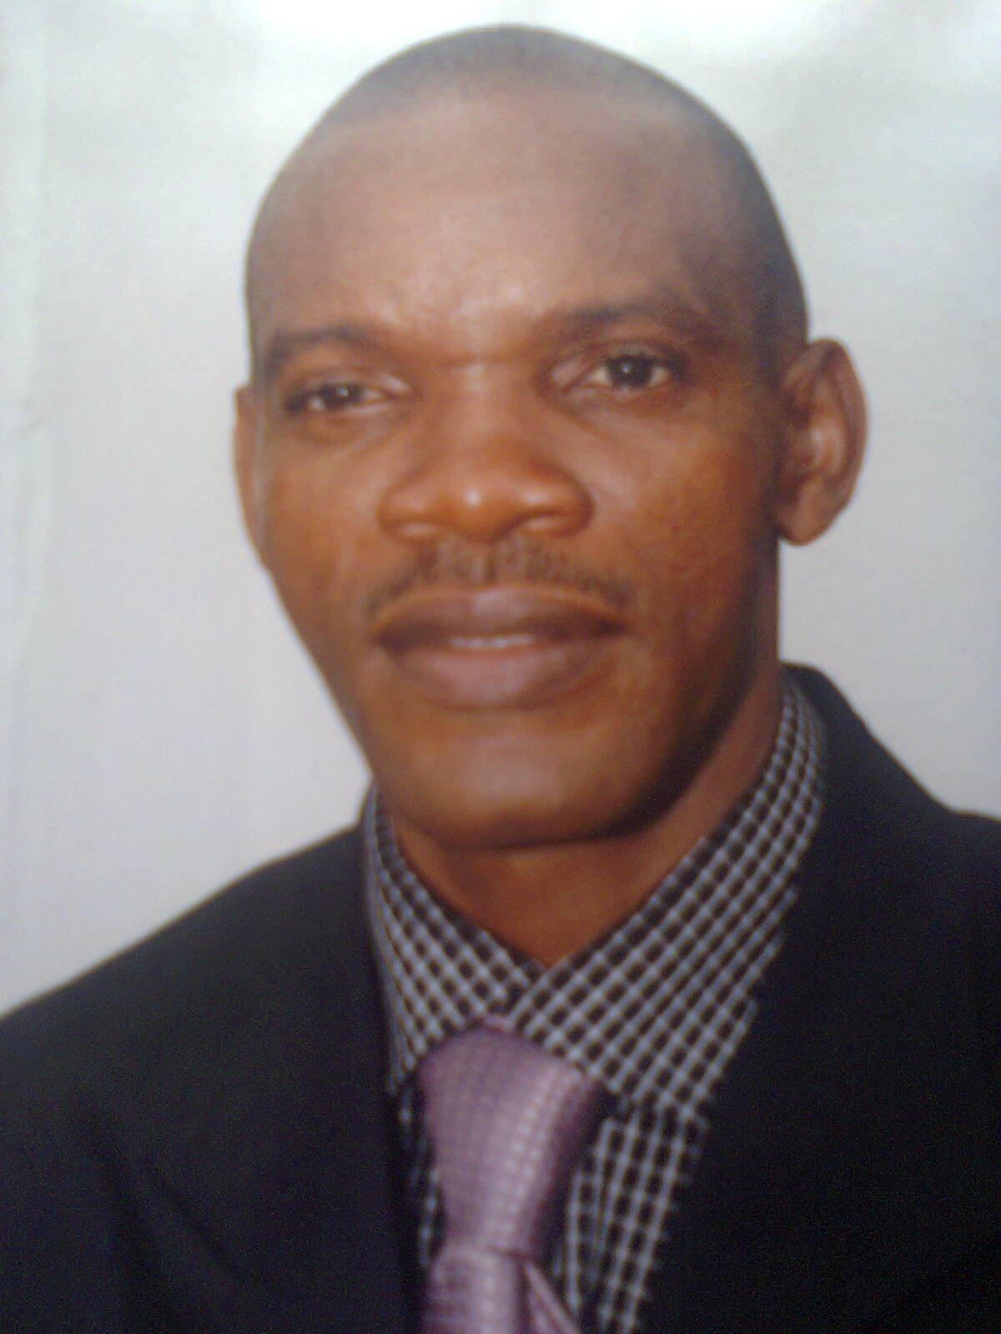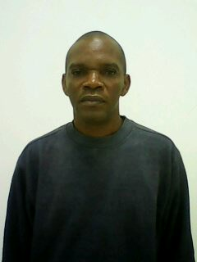

JONATHAN

DATE OF BIRTH: - 18TH AUGUST, 1969
STATE OF ORIGIN: - IMO STATE
NATIONALITY: - NIGERIA
MARRITAL STATUS: - MARRIED
LOCATION: - NIGERIA
E-MAIL: - jonathan.343041@2freemail.com

S/N | INSTITUTIONS ATTENDED | DATES
1 | M&O Blisston Tropical BOSIET Course | 2016
2 | Offshore Safety Training | March 2011
3 | Defensive Driving Course | 2005- 2010
4 | The Polytechnic Ibadan | 1998 – 2000
5 | The Polytechnic Ibadan | 1995 - 1997
6 | Government Technical College, Abeokuta | 1981 – 1986
7 | Umualum Primary School Nekede, Owerri | 1975 - 1981

S/N. | QUALIFICATIONS | DATES
1 | Basic Offshore Induction & Emergency Training (BOSIET) OPITO Approve | November 2016
2 | Helicopter Underwater Escape Technique (HUET) & Survival At Sea (SAS) Course | March 2011
3 | Defensive Driving Certificate | 2005 - 2010
4 | HND (Electrical & Electronics) | 1998 – 2000
5 | OND (Electrical & Electronics) | 1995 – 1997
6 | West African Education Certificate (WAEC) | 1981 – 1986
7 | First School Leaving Certificate | 1975 – 1981

S/N | WORKING EXPERIENCE | POST HELD WITH DATE | ACTIVITIES CARRIED OUT
1 | P.G.H Quarry, Abeokuta | Electrical Technician  1986 – 1989 | I handled the daily Repairs & Maintenance of Electric motors, Contactors, welding machines & other Electrical Apparatus in the Quarry.
2 | Nigerian Army School of Electrical & Mechanical Engineering, Auchi. | Electrical Technician  1990 – 1995 | I handled the Repairs & Maintenance of Generators, Armored Cars, and Welding Machines & Electric Motors.
3 | Chevron Nigerian LTD, Escravos | 1997-1998 Electrical/Instrumentation Technician (Industrial Training) | I did Installations, Repairs & Maintenance of Instruments such as, JBS, JBC Panels, Electric Motors, Electro Valves, Pressure Gauges, Shut Down Valves (SDV), ESDV, BDV, Gas Detectors, Flow Pumps and Cable Termination in the Panels.
4 | Nigerian Caterers Ltd. I.A. Restaurant, SPDC, Port-Harcourt. | Electrical Engineer  2000 – 2003. | I was Head of Repairs & Maintenance of Kitchen Equipments such as, Cookers, Boilers, Ovens, Mixers, Cold room & Other Kitchen Equipments.
5 | British Oil and Gas Exploration Ltd (BOGEL) Owerri, Imo State. | Rig Sit Electrical Technician 2003 -2005 | I carried out the Maintenance, Repairs and Services of TDS and Kelly Draw Works, Mud Pumps & other Electrical Appliances.
6 | Shell Petroleum Development Company, Port Harcourt. | Electrical & Fire alarm Maintenance  (Team Leader).  - – 2012. | I handled the Installation, Maintenance and Servicing of Electrical high & low voltage Panels, DBs Breakers and other Appliances.  Fire Alarm & Smoke Detectors, Fire Alarm Panel Programming, Scoping, Designing, Installations and Maintenance.  - Participated in the servicing of firefighting equipment  - Participated in the Risk Assessment for all jobs to be done.  - Carried out fire stand-by duties and hot work stand-by duties using fire fighting equipment, breathing apparatus and specialist rescue equipment during plant routine maintenance and emergency situations.  - Conducted daily maintenance and testing of fire hydrants and isolation valves.  - Carried out daily test and cleanining of all fire equipment.  - Involved in the maintenance of fire Suppression systems, FM 200.  - Participated in the testing of fixed fire protection systems in line with Fire system testing and maintenance procedures.  - Participated on a daily basis in both practical and theoretical training to maintain the required professional skills.
7 | Omotosho Generation Company LTD (NIPP 500MW Project) Ondo State. | Electrical & Fire Alarm ( Team Leader) Dec,2012 Till Date | I carry out Scoping, Evaluation, Installation, and Maintenance & Servicing of Electrical high & low voltage Panels, DBs, Breakers, Electric Motors and other Appliances.  I Handle Fire Alarm Systems, Panel installations and programming.  Day to day maintenance of Fire Suppression Systems, programming, scoping, FM 200.  Conduct Fire Risk Assessment.  Prepare of Job Hazard Analysis (JHA) before any Job is carried out and  Implement PTWs.

KEY STRENGHTS
- Fire prevention and Safety
- Excellent communication and problem solving skills.
- Effective use of initiative with minimal supervision.
- Unflinching integrity and transparent honesty.
- Interesting team player with physical and mental alertness. Strong supervision and people management
SUMMARY:
I have 30 years experience and can work anywhere and anytime.

