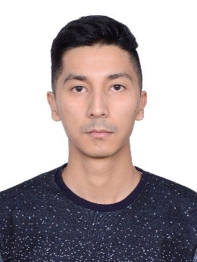

PERSONAL DETAILS
DOB: 24/03/1993
NATIONALITY: Uzbekistan
MARITAL STATUS: Single
VISA: Tourist visa

SKILLS
PERSONAL
- Hard worker
- Great communicator
- Fast learner
- Team player
- Leadership skills
- Problem solving skills
- Great advisor
- Self-motivated
- Positive attitude
- «Can do» attitude

ERMANOV
e-mail: ermanov.343064@2freemail.com
C/o-phone: +971505891826

PERSONAL SUMMARY
I am a mature, positive and hardworking individual, who always strives to achieve the highest standard possible, at any given task. I posses excellent communication skills and I have the ability and experience to relate to a wide range of people. I enjoy learning new things, I can work very well under pressure and I have the sales experience to handle customer complaints and solving problematic situations.

EXPERIENCE
- SALES ASSOCIATE at «Wardrob» shop (2015-2016)
(Navoi, Uzbekistan)
- SHOP ASSISTANT at «GULI MARKET» (2014-2015)
(Navoi, Uzbekistan)
- SALES ASSISTANT in sport shop (2013-2014)
(Donetsk, Ukraine)
- SECURITY GUARD in hotel «ZARAFSHAN»(2011-2012)
(Navoi, Uzbekistan)
- FITNESS TRAINER in the fitness club at the «Grand M»
(2010-2011) (Navoi, Uzbekistan)

Duties:
- Offered customers with exemplary and timely service
- Provided accurate product information
- Enhanced product knowledge utilizing limited resources
- Organized and cleaned store during downtime
- Handled cash, checks, and credit card transactions
- Addressed loss prevention issues immediately
- Merchandised, restocked and maintained sales floor
- Built and maintained internal and external customer satisfaction
- Processed shipments and ensured all merchandise is represented on the floor
- Welcoming customer in a friendly manner
- Providing demonstrations to customers on items in the store
- Assembling merchandise in the store and windows.

HOBBIES & ACTIVITIES
Computers, Microsoft Word, Microsoft Excel
Xerox, Scan
Music, swimming, training.

EDUCATION
- Navoi College of Medicine
(09/2010-05/2013)
Diploma in Russian
- Donetsk National Medical University
(09/2013-05/2014)
incomplete higher education

LANGUAGES
UZBEK Native language
ENGLISH Good reading and speaking ability.
TURKISH Good reading and translating ability.
RUSSIAN Fluent reading, writing and speaking ability.

