Ezra

Graphic Designer & UI/UX Developer

ABOUT ME
.............................................................................................................................................................................

Hello ! I’m Ezra Gunn a freelance graphic and web designer from Kuala Lumpur (Malaysia). I grown passion for web and graphics design which makes me love working with web design & development and graphic design. Mainly, I translate mockups into codes made up of HTML and CSS.

I have 1 year of experience working as a freelance and working with young entrepreneurs, 1 year with startup and I’m ready for an opportunity to enhance my skills for better art work !

Interested? View more of my details !

MY SPECIALITIES
.............................................................................................................................................................................
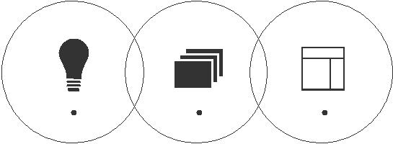

Logo Design |  | Minimal Web Design

Branding

 |  |  | Contact |  | Ezra.343071@2freemail.com
 |  |  |  |  | +971502360357

TIMELINE
.............................................................................................................................................................................

From May 2010 to May 2013.

Diploma IT specialism in Software Engineering

Asia Pacific University

From May 2013 to May 2015

BSc (Hons) IT specialism in Information System Security

Asia Pacific University

From June 2015 to March 2016

Delivery Graduate - C# Coded UI

BAE Systems Applied Intelligence

From June 2015 to July 2015

Completed DaBull Fashion Project (Web Design)

Freelance

From November 2015 to November 2015

Completed Jvape Project (Logo Design)

Freelance

From April 2016 to Present

UI/UX Developer

Netccentric Ltd

DESIGN SKILLS |  | HOBBIES & INTERESTS
............................................................................................................................................................................. |  | .............................................................................................................................................................................
Tools | Knowledge/ Design Senses
Adobe Photoshop | Grid & Layout.
Adobe Illustrator | Sense for typography. | Cinema | Photography | Music | Videogames | Android
Atom | Color theory knowledge.
Ionic Framework | Image editing.
HTML & CSS | Interface Design.
AngularJS & JQuery | Logo Design
Draw.io | Responsive Web
Angular Material |  | Travelling | HTML5 | Fitness | Desserts | Facebook
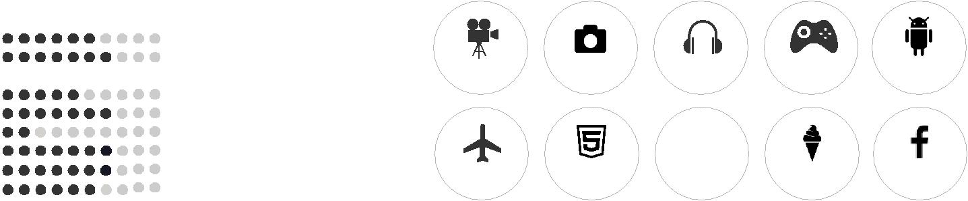
SASS

React Native JSX

LANGUAGE SKILLS

.................................................................................................................................................................................................................................................................................................................................................................
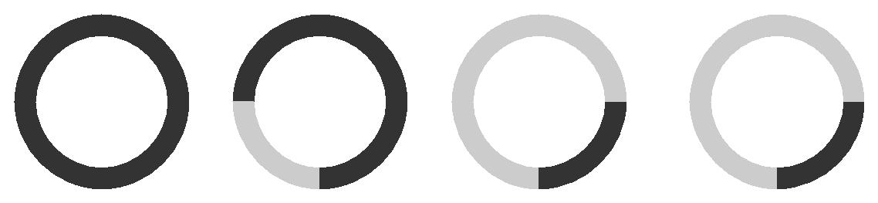

CHINESE ENGLISH MALAY CANTONESE

Mother language Advanced level Basic level Basic level

