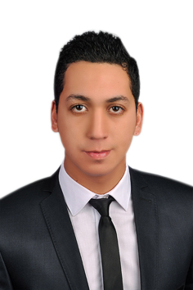
Khaled
Al Nahda – Dubai
C/o- +97151685421
khaled.343100@2freemail.com

PERSONAL INFORMATION
Date of Birth: 31\10\1990
Gender: Male
Marital Status: Single
Nationality: Egyptian
Military Service: Completed
Religion: Muslim
Egyptian Driving License: Available
Visa Type: Visit Visa

ACADEMIC QUALIFICATIONS
B.SC of Civil Engineering
University of Alexandria –(June 2013)
- Grade: Good
- Graduation Project: Material Project
- Properties of Recycled Aggregate Concrete
- Quantity surveying of 6 floors skeleton
- Grade of graduation project: Excellent

EXPERIENCE
- EL SEWEDY POWER SYSTEM PROJECTS (PSP)
Construction Civil Engineer / Dec 2015 to Nov 2016

BeniSuef 4800 Mw Combined Cycle Power Plant (Fast-TrackProject)
- Power Block Area ( RC Concrete Buildings )
- Managing Steam Turbines Area
- Closely monitor site activities and conduct inspections to ensure quality of work
- Observe site safety practices
- Steel Structure
- Develop Site-specific Erection Plan
- Identify Lifting plan
- Sequence of erection activities
- Prepare daily progress sheet and compare with schedule plan
- Key Stone Walls
- Managing and executing key stone walls (retaining walls) of 16 meter height.
- Perform Quality Assurance process and make daily reports for the activities done.
- Identify the potential thresholds and take corrective or preventive actions.

- EL SAYES CONTRACTING COMPANY
Site Engineer / Jan 2014 to Oct 2015

- Residential Buildings
- Executing and following up the works.
- Identify the project expected problems and get the solution at the site.
PROFESSIONAL CERTIFICATES
- PMP (Project Management Professional)
Evorestte - Dec 2015

- Covering All the Project Management Knowledge Areas
- Primavera
- Work Shop (Gas Turbine Power Plant)

- AutoCAD 2010, “2D”
Behera Engineers Syndicate -July 2012

SKILLS
- Languages
Arabic: Mother tongue
English:Very good (Speaking, Reading, Writing and listening)

- IT
Primavera, AutoCAD “2D”, SAP2000, MS Office (Excel and Word)

INTERPERSONAL SKILLS
- Interpersonal communication skills
- Building trust
- Resolving conflicts
- Active listening
- Overcoming resistance to change

INTERESTS / HOBBIES
Football, Running, Travelling, Technology, Art.

All certificates are available upon request

