CURRICULUM VITAE
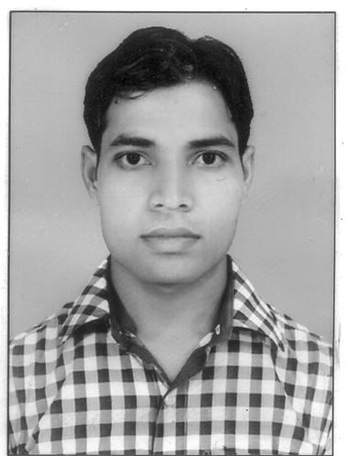

Name : Snaullah
C/o-Contact No : +971504973598
Email Id : snaullah.343173@2freemail.com

Sub: Application for the post of “Assistant Accountant”.
OBJECTIVE:-
To achieve success by constant working & complete the assigned work by applying my skills to achieve goal.
EDUCATIONAL QUALIFICATION:-
Degree | Board/University | College/School | Year of Passing | Percentage
B.Com(Hons)in Account | Magadh University | T.S.College (Hisua) | 2013 | 60.20 %
H.S. | BSEB Patna | T.S. College(Hisua) | 2010 | 63.60%
Matriculation | BSEB Patna | Hisua High School(Hisua) | 2008 | 51.85%
TECHNICAL QUALIFICATION:-
- CIA(Certified Industrial Accountant) Tax from ICA(The Institute of Computer Accountant) InfoTech, Kolkata (West Bengal)India
- Financial Accounting From Aptech, Nawada (Bihar)India
EXPERIENCE:-
- 3 Years Working as Assistant Accountant in Century Ventures Pvt.Ltd. Patna (Bihar)
SKILL SET:-
- M.S. Office:-(Word, Excel,& Power Point)& Internet
- Accounting Software:-Tally ERP9
LANGUAGE KNOWN:-
- ENGLISH
- HINDI
- URDU

PASSPORT DETAILS:- : DATE OF ISSUE : 13.05.2015
: DATE OF EXPIRY : 12.05.2025
: PLACE OF ISSUE : PATNA
PERSONAL DETAILS:-
Date of Birth | 15th May 1992
Nationality | Indian
Religion | Islam
Marital Status | Unmarried

DECLARATION:-
I confirm that the information provided by me is true to the best of my knowledge and belief.

