NETWORK/SYSTEM ENGINEER

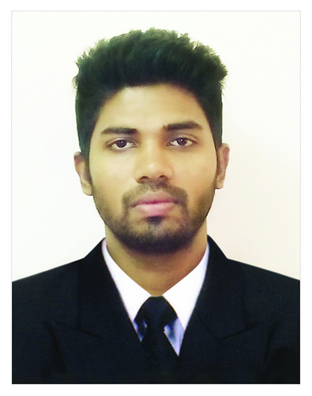

AMAR
Abu Hail, Dubai
United Arab Emirates
Email: amar.343188@2freemail.com

OBJECTIVE

Aspiring to be a leading professional in the field of computer science & engineering, where I can utilize my skills to the maximum and to lead the organization to newer heights. An able and innovative learner who can grasp processes and procedures quickly, easily adaptable to any environment and assure 100% dedication and responsibility to the duties conferred on me.

PROFESSIONAL EXPERIENCES

- Worked as System & Network Administrator at SPARK FIRE SAFETY EQUIPMENTS, Trivandrum, Kerala, India(An ISO 9001:2008 Certified Company) from 2-Feb-2016 to 10-February-2017 and my duties are:
- LAN, WLAN Infrastructure implementation
- Windows/Linux Server and Desktop Support
- Installation and maintenance of Security Surveillance Systems:
CCTV, Access Control, Burglar Alarm and Door Video phone

Designation | Company | Period |  | Duties:
 |  | From | To
- Network Engineer | Green Technologies, Kochi, India | May-2015 | Jan-2016 | Network Engineering  CCTV installation  Security system implementation
- System & Network Administrator | IIB Education, Thrissur, India | Mar-2014 | Apr-2015 | Linux/Windows System Administration  Network Administration  Computer System Service & Assembling
- Junior System Engineer | Metclouds Technologies, Kochi, India | Aug-2013 | Feb-2014 | Linux Server Administration  Web server live service  C-panel/WHM live e-mail customer service

EDUCATIONAL QUALIFICATIONS

Course | Institution | University | year | Percentage
B.Tech  (Computer Science & Engineering) | IES College of Engineering, Chittilappilly, Kerala, India | University of Calicut | 2013 | 67.5 %
Plus Two  (VHSE Computer Application) | GMBVHSS, Irinjalakuda, Kerala, India | Kerala State Board | 2008 | 79.13 %
SSLC | St:Antony’s HS, Murkkanad, Kerala, India | Kerala State Board | 2006 | 69.73 %

CERTIFICATION

- RHCE,RHCSA(Certified130-193-014)
- Diploma in Computer Hardware Assembling & Servicing Training from JAWARHARLAL NEHRU EDUCATIONAL FOUNDATION,(India)
- Multimedia and 3D Animation Specialist Training from NOVA MULTIMEDIA EDUCATION, India

EXPERTISE

- Administration of Windows and Linux Operating system.
- Computer Hardware& Networking, maintenance and services.
- Good knowledge in Desktop publishing (DTP) and its software.
- Graphic Design software : Photoshop, Illustrator, CorelDraw, 3D Max
- Video/Audio Editing : Power Director, Audacity
- Programming Languages : .Net, Visual Basic.

ACADEMIC PROJECT DETAILS

- Mini: GSM BASED ADVANCED CALL CENTRE USING PC

Period : 1 month (Academic year 2011-2012)
Description : Advanced automated version of call center using GSM module and Personal Computer, it handles operations like adding and manipulating contact details, SMS, voice calling and so on.

- Main: COOPERATIVE DOWNLOAD IN VEHICULAR ENVIRONMENTS

Period : 2 months (Academic year 2012-2013)
Description : A high speed system for large sized file downloading in vehicular
environment by equipping Wi-Fi system to the vehicles, the downloaded packets.

ACHIEVEMENTS
- Participated National Level Redhat Workshop conducted by HCL.
- Participated N.S.S Volunteer Leader’s Training Camp
- Successfully completed training of Kerala State Entrepreneur Development Mission(KSEDM)
- Achieved Second place for PECSAGA Inter-College Cricket Tournament
- Participated in sports and arts competitions in college and won prizes.

PERSONAL
Nationality : Indian
Sex : Male
Marital Status : Single
Date of Birth : 1st June, 1990
Visa Status : Visiting
Languages : English, Hindi, Malayalam
Interests : Reading, Drawing, Music, Sports & Games

DECLARATION
I hereby declare that all particulars mentioned in this document are true and fair to the best of my knowledge and belief.
AMAR.

