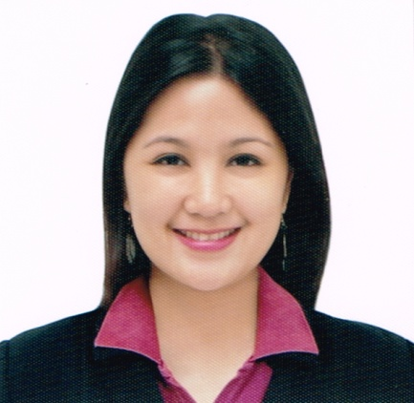
Maria
Sharjah UAE
C/o- +971505891826
maria.3343189@2freemail.com
Position Apply: Receptionist/Billing Clerk/Office Work
______________________________________________________________________________

OBJECTIVES

I am seeking employment with a company where I can use my talents and skills to grow and expand the company. I want to succeed in a stimulating and challenging environment, building the success of the company while I experience advancement opportunities.

PERSONAL INFORMATION

Age : 24
Date of Birth : May 16, 1992
Gender : Female
Civil Status : Single
Height : 5’4”
Weight : 56 kg.
Nationality : Filipino
Religion : Roman Catholic

EDUCATIONAL ATTAINMENT

Tertiary : Lyceum of the Philippines University
Capitol Site, Batangas City
Bachelor of Science in Computer Science
2011- 2015

Secondary : Batangas National High School
Rizal Avenue, Batangas City
2004-2008

Primary : Sta. Clara Elementary School
Sta. Clara Batangas City
1998-2004

PROFESSIONAL EXPERIENCES

BILLING CLERK (JUNE 10, 2016 – DEC. 15, 2016)
United Doctors of St. Camillus De Lellis Hospital
Diversion Road, BolbokBatangas City

Duties and Responsibilities

- Gathers Billing information by reviewing patient’s hospital records; checking for completeness.
- Ensures payments by verifying accuracy of data/records.
- Bills by inputting billing information to database; initiating manual/electronic transmission.
- Reviews patients bill for accuracy and completeness and obtain any missing information. Resolve discrepancies by examining and evaluating data; selecting corrective steps.
- Update job knowledge by participating in educational opportunities; reading professionals’ publications, maintaining personal networks; participating in professional organization.
- Maintains safe and clean working environmental work flow and efficiency by fostering spirit cooperation. Also coordinates properly to ensure efficient work result.
- Performs other duties as may be assigned or designated for purposes of ensuring the efficient and effective functioning and operations of the work unit.

INFORMATION/PABX/ADMITTING STAFF (JUNE 10, 2015 – JUNE 10, 2016)
United Doctors of St. Camillus De Lellis Hospital
Diversion Road, BolbokBatangas City

Duties and Responsibilities

- Operate communication systems, such as telephone, PABX/switchboard, intercom.
- Handle all directory assistance quires.
- Interrupt a busy line if there is an emergency.
- Perform receptionist functions as needed.
- Answer incoming calls, greetings callers, providing information, transferring calls and /o taking messages as necessary.
- Page individuals to inform them of telephone calls using paging and interoffice communication equipment.
- Perform other duties as assigned to the purpose of ensuring the efficient and effective function of the work unit.
- Maintains patient confidence by keeping patients record information confidential.
- Interview incoming patients or representative and enters information’s required for admissions into computer.
- Explain hospital regulations such as visiting hours, payment accounts and schedule of charges.
- Enter patient admitting information into computer routes printed copy to designated department.
- Obtain assigned patient room or ward.
- Compiles data for occupancy and census records.

GUESS (MARCH 2010 – JANUARY 2011)
STOCK CLERK/SALES ASSOCIATE
SM Batangas

PROFESSIONAL STRENGTHS

- Open to learn new ideas.
- Improving efficiency on assigned tasks.
- Ensure tasks are completed correctly and on time.
- Ability to work in a team.
- Self-motivated and hardworking.

TECHNICAL PROFICIENCIES

- Excellent in written and communication skills (English and Tagalog language)
- Knowledge in Cisco Networking
- Software Applications (Microsoft Office –Word, Power Point, Excel and Outlook)

SEMINARS AND TRAININGS ATTENDED

SEMINAR AND WORKSHOP ON “CUSTOMER SERVICE”
United Doctors of St. Camillus de Lellis Hospital
February 19-24, 2016

FIRE BRIGADE & SAFETY
United Doctors of St. Camillus de Lellis Hospital
August 5-10, 2016

PERSONALITY DEVELOPMENT
United Doctors of St. Camillus de Lellis Hospital
November 12, 2016

