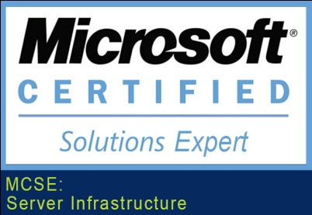
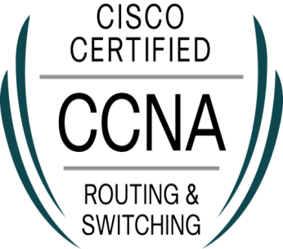
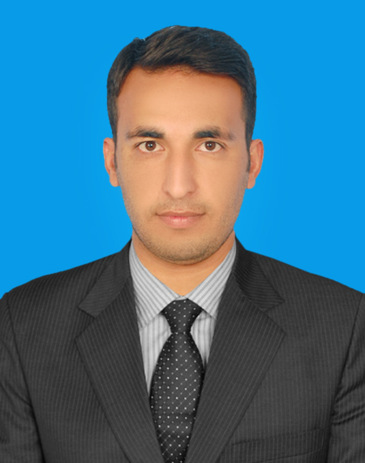

MAAD
IT Engineer/IT Support Engineer
C/o- Cell # +971502360357 Email: maad.343203@2freemail.com
Nationality: Pakistani
DOB: 20/12/1992

Objective

An Enthusiastic and versatile IT Engineer/IT Support Engineer with a Excellent commands in Installation, configuration and administration of Window Servers 2012/2008R2. Cisco IT infrastructures – Cisco switches, routers, Firewalls and network protocols. Currently looking for a suitable position with a reputable and forward looking company.

Employment Record

Organization: Fauji Foundation Hospital (FFH)
Designation: Assistant Engineer (IT/NETWORKS)
Duration: Since 05 JULY 2015 to 15 JAN 2017
Role & Responsibilities:

- Maintaining overall IT infrastructure of the organization.
- Deployment and management of Windows Servers 2012R2. Administered Windows Server Active Directory including Group Policy Object.
- Implementation of Rights Assignment/Restriction on specific users or Group.
- Managing DHCP,DNS,DC,DFS,FSRM,WDS Via RSAT.
- Installing and configuring networking devices printers, scanners, switches, and routers.
- Managing Exchange Server 2010 Creating/Removing users, creating distribution groups, mailboxes, address list, increase Quota Limit, managing databases and applying policies for better management and security.
- Configuring emails for the staff in the Microsoft outlook mail clients and mobile devices.
- Enabling and implementing file sharing & security through File server.
- Prepare proposals for purchasing new equipments for instructional purposes.
- CISCO routers & switches configuration backup Via TFTP.
- Implementation of Backup and Disaster Recovery policy.
- Lan Cabling, Troubleshoot Network connectivity problems.
- Provide technical support to all levels, troubleshoot hardware and software issues physically and remotely via Team viewer.
- Achievement: Was the member of the team for establishing LAN of Fauji Foundation Hospital.

QUALIFICATION

- Bachelor in Software Engineering (2011-2015)
University of Engineering and Technology UET Taxila, Pakistan.

- Higher Secondary School Certificate in Computer Science ( 2010-2011)
Hamza Army Public School and College Rawalpindi, Pakistan.

- Secondary School Certificate in Computer Science ( 2009)
Joint Staff Public School Rawalpindi, Pakistan.

Certification

- MCSA (Window Server 2012)
- MCSE (Server Infrastructure)

CCNA (Routing and Switching)

Professional Training

- CCNA(Routing and Switching)
- CCNA SECURITY
- CCNP(Routing and Switching)
- MCSA (Window Server 2012)
- MCSE(Server Infrastructure)

Networking Skills

Server Infrastructure:
Expertise in Managing Microsoft Window Servers 2012/2008R2 Network Infrastructure including DHCP, DNS, Domain Controller, Active Directory User management, Group Policy, File and Data shearing, Backup and Restore, Clustering, Print and Document Service, Windows Deployment Service(WDS), ADCS, ADRMS, DFS, FSRM, WSUS, FTP Server, Exchange Server 2010, RSAT Tools, Event Viewer, Virtualization: VMware, Hyper-V.

Routing & Switching:
- Experience of configuring Cisco Switches “2950, 2960, 3550, and 3560”.
- Experience of configuring Cisco Routers “2500, 2600, and 2800”.
- Skilled in designing LAN by using ECNM (Enterprise Composite Network Model).
- Configure and troubleshoot VLAN,Trunking, and Inter-VLAN Routing (router on a stick and SVI).
- Configuring and troubleshoot VTP,STP,RSTP,MSTP and different STP Features Uplink Fast, Backbone Fast, Port Fast etc.
- Configuring Layer 2 and 3 EtherChannel (LACP/PAGP).
- In depth working knowledge of Routing Protocol such as static routing, RIP,
EIGRP, OSPF, BGP, and Redistribution b/w Routing Protocols.
- Router Configuration backup and Restore using TFTP.
- Excellent Command on Router Redundancy Protocol such as HSRP, VRRP and GLBP.
- Configure DHCP and DNS on Router.

Security:
- Configure AAA Security.
- Configure Router Privilege Levels/Privilege Views.
- Implement Port-security and MAC Filtering.
- Configure site to site IPSEC VPN Tunnel in Cisco Routers.
- Excellent Command on Traffic filtering using ACL (standered, Extended, and Time Based)
- Configure Telnet and SSH.
- Configure and troubleshoot NAT, PAT, NTP and SNMP on a Router.

Other Skills

- Expertise in Programming Languages like C++ & JAVA.
- Excellent Command on WORDPRESS, SEO, Blogging, Web Design and Development.
- Good Knowledge of Oracle Database.
- Excellent Command on MS Office (Word, Excel, Access, PowerPoint).

Languages Known

English, Urdu, Hindi, Punjabi, Pashto.

I am a hard working person and have the ability to work effectively both independently and as a member of a team. I try to fulfill and execute all the work entrusted to me on an utmost satisfactory Level. All the above specified information is true to thebest of my knowledge.

Maad

