Curriculum vita

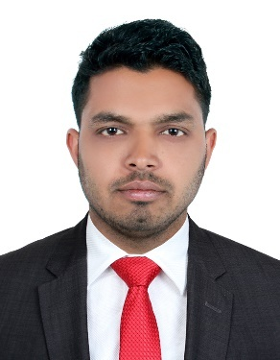

BABLU
bablu.343217@2freemail.com
C/o- +971505891826

Carrier Objective
To be a member of the core team of the organization through my analytical skills and dedication by contributing consistently towards the growth of organization and personal career development.

ACADEMIC QUALIFICATION

Course | Specialization | Board/University | Year | Percentage | Class | School/College
H.S.C | INTER | J.A.C | March  2008 | 57.8% | 2nd Class | J.K.S .COLLEAGE
S.S.C | MATRIC | J.A.C | March  2006 | 52.4% | 2nd Class | R.V.M.H.SCHOOL

Computer Skills

- Ms Office (Ms Word. Ms Excel, MS power Point)
- Internet

Working experience

Worked in BAJWA SURGICALS from Aug 2012 to Jan 2017 as a Sales
Executive in India.

Job description:
- Product description
- Listing Customers demands
- Customer service
- Product knowledge
- Selling to Customer needs
- Flexibility with Customers

Worked in MEDICA HOSPITAL from Jan 2009 to April 2012 as a Customer
Service in Indian.
- Work in medical store
- Medicine distribute as per customer required
- Stock maintained
- Customer satisfaction

PERSONAL DETAILS

DOB : 22 DCE 1989
Sex : Male
Nationality : Indian
Visa Status : visit Visa
Language known : English,Hindi
Religion : Hindu
Marital Status : Single

